

A+



Wifi Standards

| IEEE  Standard | Operating  Frequency | Typical Data Rate | Maximum  Data Rate | Indoor Range | Outdoor Range |
| --- | --- | --- | --- | --- | --- |
| 802.11b | 2.4 Ghz | 6.5 Mbps | 11 Mbps | 35 Meters | 100 Meters |
| 802.11g | 2.4 Ghz | 25 Mbps | 54 Mbps | 25 Meters | 75 Meters |
| 802.11n | 2.4 Ghz or 5 Ghz | 200 Mbps | 540 Mbps | 50 Meters | 125 Meters |
| 802.11ac | 5 Ghz | 2.5 Gbps | 6.9 Gbps | 50 Meters | 125 Meters |



Bluetooth Classes

| Device Class | Transmit Power | Intended Range |
| --- | --- | --- |
| Class 1 | 100 mW | 100 Meters (328 feet) |
| Class 2 | 2.5 mW | 10 Meters (33 feet) |
| Class 3 | 1 mW | Less than 10 Meters |

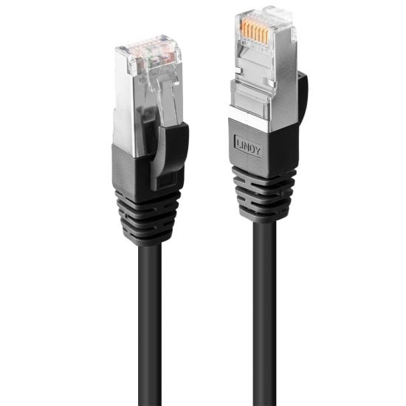

Cable Categories

| Type | Speed | Common Use |
| --- | --- | --- |
| CAT1 | 1 Mbps | Phone lines |
| CAT2 | 4 Mbps | Token ring networks |
| CAT3 | 16 Mbps | Ethernet networks |
| CAT4 | 20 Mbps | Token ring networks |
| CAT5 | 100 Mbps | Ethernet networks |
| CAT5e | 1 Gbps | Ethernet networks |
| CAT6 | 10 Gbps | Ethernet networks |
| CAT7 | 10 Gbps |  |



|  |  |  |
| --- | --- | --- |
| Service | Port | Description |
| Apple filing protocol (AFP) | TCP 548 or 427 | Formerly called AppleTalk Protocol; file services macOS |
| Common Internet file system | TCP 445 | A version of Server Message Block (SMB) |
| Domain Name System | UDP 53 | Used by DNS clients to perform DNS queries against clients |
| Dynamic Host Configuration Protocol | TCP/UDP 67/68 | Used for assigning IP addresses to clients |
| File Transfer Protocol (FTP) | TCP 20/21 | Transfers file between an FTP client and FTP server |
| Hypertext Transfer Protocol (HTTP) | TCP 80 | Web page transmission to the web browser |
| HTTP over Secure Sockets Layer/Transport Layer Security | TCP 443 | Secure transmission of web pages |
| Internet Message Access Protocol (IMAP4) | TCP 143 | Retrieves e-mail; advanced features beyond POP3, such as folder synchronization |
| Lightweight Directory Access Protocol (LDAP) | TCP 389 | A standard method of accessing a network database; often used for authenticating user accounts during a user logon |
| Post Office Protocol Version 3 (POP3) | TCP 110 | Retrieves e-mail from a POP3 mail server |

Well known Ports



|  |  |  |
| --- | --- | --- |
| Service | Port | Description |
| Remote Desktop Protocol (RDP) | TCP 3389 | Used remotely access a Windows desktop |
| Secure File Transfer Protocol | TCP 22 | Uses an SSH-encrypted terminal emulation that replaces telnet |
| Secure Shell (SSH) | TCP 22 | Secure (encrypted) terminal emulation that replaces Telnet |
| Server Message block | TCP 445 or TCP 137 -139 | Windows file and print sharing service |
| Service Location Protocol (SLP) | TCP/UDP 427 | A LAN service discovery protocol used by older versions of macOS, NetWare, and some LAN–enabled printers |
| Simple Mail Transfer Protocol (SMPT) | TCP 25 | Sending e-mail |
| Simple Network Management Protocol (SNMP) | UDP 161/162 | Queries network devices for status and statistics |
| Telnet | TCP 23 | Terminal emulation; all data sent in clear text |
| Trivial File Transfer Protocol | UDP 69 | Differs from FTP in that there is no option for authentication |
|  |  |  |