Storage Networks
Daniel J. Worden

Chapter 1: A Walk Around the Technology

Overview
In this chapter, I take you on a tour through the various components that make up a storage subsystem, paying particular attention to identifying areas of contention and bottlenecks. You'll learn the true definition of "bandwidth" and get a look at several areas that can affect the real data transfer rate through a system and across a network.
This chapter explores the role of specifications as a means of encouraging interoperability. I review several of the most useful standards for evaluating storage networks and appraising offerings from different vendors.
As befits an introductory chapter, I begin with the fundamental concepts and take you through the internals of representative storage network systems, and the paths bits take through them. Then I layer on general networking concepts, with specific attention to contributions to the increase in throughput and how that enables storage networks.
Emerging protocols such as iSCSI and 10 Gigabit Ethernet are covered in the context of where they fit in the overall scheme of storage network options and how they affect design and deployment decisions today and possibly in the future.
By the end of this chapter, you should have a feel for the end-to-end path a data packet has to travel as part of even the simplest storage solution, as well as the standards and products involved in large-scale networked storage solutions.

Getting Started
Like everything digital these days, Storage Area Networks (SANs) are inherently complex. This makes them difficult to manage, in part because of the sheer number of contributing components offered by different vendors. Add to this the need to layer software and procedures on top of a SAN in order to gain the expected benefits, and, for many, storage network components represent a jumble of puzzle pieces.
The premise of this book is that you can more quickly understand SAN technology, in theory and practice, if I organize my approach a bit differently. Whereas many technology authors start at the "big picture" and drill down, I'm going to take a different approach and start from the foundation and work up.
Yet, even within this basic approach, a couple of wrinkles need to be ironed out from the beginning. Storage Area Networks are, on an important level, less about storage and more about networking. The good news is that by limiting the scope of the network to storage, I can contain some of the complexity around networks in general and cover the material with a view to one particular kind of application.
The other piece of good news is that, although outside of the mainframe environment SANs are relatively new (say post-Windows 95), Local Area Networks are not. So I propose to start there.

The Network is the Computer—Again
Sun Microsystems used to say, "The Network is the Computer." Sun's marketing material in 1987 was printed with this slogan when the company was promoting clusters of engineering workstations, and Sun resurrected it in the late 1990s when it was promoting the Internet as the network to bring everything together. It's interesting to me that the performance of my old Sun 3/50, 10Base-2 network, with its little black RG-58u coaxial cable, has about the same throughput and ping speed as my current Southwest Bell ADSL modem and wireless network. Old LAN performance equates to new small office/home office Wide Area Network (WAN) performance.
That observation isn't made idly; it's a recurring theme as I show you the different offerings for interconnecting storage subsystems. Network speeds and distances are increasing steadily, if not exponentially. If today's local access becomes tomorrow's WAN access, when it comes to storage and disk access, you can start to think "outside of the box."
The Network is the Computer: That's the motif for this chapter. Keeping that motto front and center, let's go through the process of how a generic network is created, and then layer on top of that the specific considerations that go into creating a storage network.

Class and Instance
One of the things that object-oriented programming maintains is that you approach software from the perspective of first defining a class, and after that you can create a concrete example or instance of something that belongs to that class. A class is a description of a collection of objects with common attributes, behavior, and responsibilities. Your dog Fido is an instance of the class pet. An iSCSI card is an instance of the class network controller. TCP/IP is an instance of the class protocol.
In networking, you start first with a specification and after that is published (or even a little before), a bunch of vendors run out and create products. So before you can even start at the ground level and work up, you have to identify the specifications that govern a storage network and its constituent parts. I think of this as pulling out all the puzzle pieces with straight lines and forming the outer perimeter of the puzzle first.
The point to remember is that without a specification or defined class for networking components, there wouldn't be implemented instances in the form of interoperable products. Even products ostensibly built to standards may not work and play well with those from competitors, depending on how well a particular standard has been defined. As you'll see, this is rife in some areas of storage networks. To better appreciate how this can happen, we have to start with some of the relevant specifications and consider the role they have in understanding storage network components.

In the Beginning—There was the ISO/ITU/OSI Network Model
The seven-layer ISO/ITU/OSI network model, which I'll refer to from this point on as the ISO model, was a breakthrough in computing when it was first published in 1978. Of course, those with a love of esoterica could argue that IBM's SNA standard announced in 1974, or the work done by Honeywell a few years before, were more important stepping-stones than the committee agreement. But as a step toward nonproprietary, interoperable product development to spec, it was quite significant indeed. For the practical purpose of understanding how storage networks are designed, built, and managed, you'll find the seven-layer model quite useful in organizing the options and understanding their implications.
For those who slept through that class, the ISO model consists of the seven layers shown in Figure 1-1.
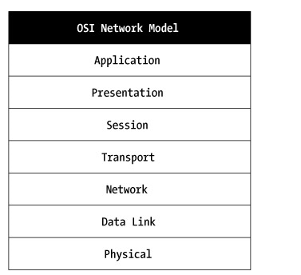
Figure 1-1: The ISO/ITU/OSI network reference model
The ground from which you'll build is the physical layer, particularly, fiber-optic cable and Category 5 (Cat 5) and higher twisted-pair copper wire. Generally, a network by definition requires more than a single computer. However, by agreeing that the network is the computer, you can approach understanding storage networks as if you were building a single computer out of subsystems: processors, memory, storage, and the means to link them all together. The extrapolation of this is that the computing resources of your entire campus, hospital, organization, or corporation can be treated as a single computer and managed accordingly.
One of the beneficial side effects of taking this approach should be an introduction to, or refresher of, the basic underlying technical considerations that must be addressed in the design of a storage network. In this chapter, I look at the various ways that bits are moved around a computer, identify the ones that impact storage and, I hope, link those concepts to the various products and topologies that make up a potential Storage Area Network.
With this goal in mind, let's review the components that make up any given hardware environment.

SAN Components
To understand how to manage a storage network, or a collection of SANs as a single logical entity, you have to first identify its components. As part of this book's approach, you'll look first at the most simple implementation of a disk subsystem. You'll see how the addition of new components adds functionality, at the expense of complexity, as you go through this process.
In Figure 1-2, you can see the constituent parts of any disk storage subsystem:
- Hard disk
- Controller
- Bus
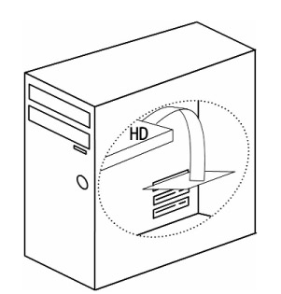
Figure 1-2: Direct attached server storage
A Network Attached Storage (NAS) appliance isn't really very different. A generic NAS is shown in Figure 1-3.
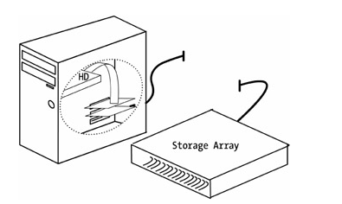
Figure 1-3: Network Attached Storage appliance
By moving the storage subsystem across the network, you can replace the controller card with a network interface card (NIC) or what is more appropriately referred to as a host bus adapter (HBA).
In a typical NAS or SAN configuration, more than one connection exists between the storage device and the server. I'll discuss multiple servers after I've covered the entire stack for a single server configuration.
Let's trace the journey of a single text file as it's retrieved by a client workstation (see Figure 1-4). If Unix is your home environment, consider an example of using the more utility to view the contents of File.txt. If you think in Windows, imagine that you double-clicked File.txt in Explorer and WordPad has requested it.
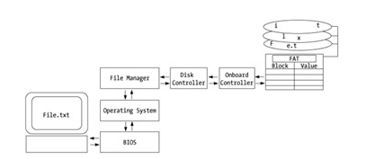
Figure 1-4: Path of a file request
As you can see, the application program sends the requested file name to the OS, which passes the request to the underlying file manager. The file manager then checks the status of the file and permissions before carrying out the request. This is to say, it looks at the file allocation table to determine the physical address of the logical file name File.txt. The hard disk heads move to the location of the file, read the bytes of which it's made up, and transfer those through the bus to RAM. The I/O processor within the OS is notified of the location in RAM and the bytes sent to the screen for your review.
The disk storage system then performs the electromechanical work of reading and passing along the bytes representing the file to the OS, which stores it in RAM and passes the first part of the file along to the standard out device, in this case the terminal by way of more or the WordPad application under Windows.
It's not a big leap to see that in a client/server environment, the disk and OS can be separated from the client by a network.
Virtually everyone has participated in this type of configuration and you probably have more than a little experience in its design, installation, and support. Of course, we're only part of the way along the path to even the most simplistic storage network.
To separate the client from the server, you need a new set of services, as shown in Figure 1-5. Specifically, you now have to manage the translation of the file through the network card of the client, the network port, and services of the server; and then invoke the process described in the previous three figures. (Again, I know this may be rudimentary to you, but explaining multivendor storage arrays, switches, operating systems, buses, and later host bus adapters requires I define and illustrate the fundamental terms.)
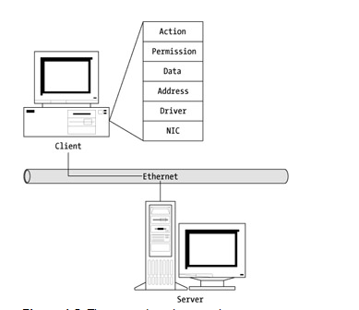
Figure 1-5: The network and protocols
At a generic level, a server-attached disk subsystem accessed by a client across the network is pretty straightforward. Let's assume that the network protocol is TCP/IP. Add to that assumption that you're using Gigabit Ethernet (GbE) over Cat 5 copper wire, and you have a good baseline for determining file access speeds over the Local Area Network. We'll have to come up with other metrics for dealing with multiple users and different types of file access, such as database transactions, but for now, let's consider that a 100-megabyte (MB) file is the baseline.
You could use the theoretical throughput speeds or even ping time to get some idea of the relative performance of the network. However, by considering file load times in increments of a single megabyte, and then looking at the appetite for storage and file size profiles, the practical work expected of a storage subsystem is going to become pretty clear. And by using this approach, you'll end up with a good rule of thumb for when determining whether direct-attached storage, network-attached storage, or a SAN is the right configuration for your particular job of work.

Host Bus Adapters
One of the main objectives of this book is to resolve some of the complexity involved in understanding Storage Area Networks. I want to do this by layering compatible sets of products together. Now that I've introduced the relationships between the components within the server, we can apply the same principles to evaluating SAN components that go outside the server—the first feature of either a NAS or a SAN.
The component that links the server with the storage subsystem is the host bus adapter. There are three main kinds of HBAs on the market at the present time—Fibre Channel, iSCSI, and Gigabit Ethernet.
Some sources will define a SAN as necessarily channel attached. That is, a system must have Fibre Channel to be a SAN. In the next breath, however, iSCSI and Gigabit Ethernet get discussed as aggressive new ways of connecting external storage subsystems to servers. This tells me that I need to treat any network scheme that links storage to servers, promoting high availability, performance, and single-desk administration, as within the scope of this book.
To work within the approach I've laid out at the beginning, I need to map a few HBAs and their protocols onto the ISO model.

Gigabit Ethernet
Not that long ago, Ethernet was doomed (it was said) to be restricted to the 10 Mbps of 10Base-T. Then a breakthrough occurred with the introduction of 100Base-T, or 100 Mbps over twisted-pair Cat 5 cable. In 1998, 1000Base-T became standardized, and products followed into the market. The 10 Gigabit Ethernet specification is expected to support development of cards to replace ATM and SONET networks and take advantage of the fiber-optic cable laid for those installations.
This means that with no change to the physical network installed, or the supporting CSMA/CD and MAC protocol, Ethernets can already handle two and soon three orders of magnitude more volume and speed than they could 10 years ago.
Gigabit Ethernet can run for distances of 100 meters over copper but is also available over fiber-optic cable, with similar distances and constraints as Fibre Channel backbones.
In Figure 1-9, you can see the mapping of Gigabit Ethernet to the OSI model.
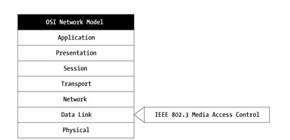
Figure 1-9: Gigabit Ethernet layers
Gigabit Ethernet, as defined in the IEEE 802.3 specification, handles the translation of the data link layer to the physical Ethernet protocol, which, as I've already noted, may be copper wire or fiber-optic cable. The upper layers are unaffected by the decision to go Ethernet, and the drivers for managing the network and transport layers also don't have to be specifically written to support the deployment of Gigabit Ethernet. Specific device drivers for the server and SAN have to be loaded, but this is to make the storage services available to the OS and applications, rather than as a result of deciding to implement Gigabit Ethernet.
One potential advantage offered by Gigabit Ethernet is a greater likelihood of interoperability between components developed by different vendors. This would be a reflection of the greater experience vendors have with Ethernet protocols, in no small part due to the much greater volume of Ethernet installations in the world.
A typical Gigabit Ethernet SAN configuration over copper wire might be for sharing tape and backup servers across a data center, especially where the existing infrastructure is limited to 100Base-T and file sizes are large enough to cause delays and network congestion.
One of the drawbacks of Gigabit Ethernet is the potential requirement for much of the TCP/IP processing to be handled by the CPU, but many vendors are now offering this functionality as part of their HBAs. It pays to check.

iSCSI
iSCSI (pronounced eye-scuzzy) is a transport protocol that allows the iSCSI host bus adapter to use existing Ethernet media as the link between the server and storage resources. In 2002, Hitachi Alacritech and Nishan Systems announced they used their existing components to achieve data transfer rates of 218 MBps.
iSCSI can be used with existing Gigabit Ethernet infrastructure or coexist with Fibre Channel SAN equipment. For installations that haven't previously installed SAN capabilities, iSCSI offers lower cost integration of storage management devices and appliances.
With Windows 2000 server and client support announced by Microsoft in the summer of 2003, iSCSI was positioned to make significant inroads for MS Exchange sites needing improved backup and availability.
As you move up the ISO stack, security considerations are introduced. At the lowest levels, you're primarily concerned with physical carrier characteristics, the effect of distances on signal propagation, the need for repeaters, and managing collisions and contention, for example. Although bus mastering allows for offloading CPU cycles to dedicated functions in the HBA, not all of these adapters handle security. Those that don't handle this function have an impact on SAN performance at either the storage controller, the CPU of the server, or both.
iSCSI has been criticized as a candidate for SAN-enabling technology because of its reliance on TCP/IP, which is vulnerable to the interception of network transmissions and having them read by a packet analyzer.
To get around this, some HBA vendors are offering IPSec and other encrypt/decrypt capabilities on their boards.

Fibre Channel
The first segregated storage arrays made available to Unix servers were Fibre Channel devices operating at a theoretical throughput of 100 MBps. In the mid-1990s, this technology supported remote copying, mirroring, and arrays of more than two-dozen disk devices. The first such device I worked with was the Sun Disk Array, and it contained 30 9GB barracuda hard disks. It was awesome, especially compared to the FastSCSI network I built to support an all-digital video production application that was limited to 20 feet of SCSI cable and no more than seven devices. Of course, iSCSI has been developed to eliminate the distance and device restrictions, but I bring this historical recollection up to show the roots of the competing architectures and just how far ahead FDDI has consistently been the enabling SAN technology.
So what has Fibre Channel done lately? Today, Fibre Channel SANs support terabytes of disk and transfer rates of up to 2 Gbps. This translates to a 2.5-terabyte-per-hour backup, for example. By the end of 2003, for the largest volumes of data to be handled in the least amount of time, Fibre Channel SANs were still the performance leaders.
The Fibre Channel model is similar to the OSI model with the notable difference of more detailed layers, which are described in Table 1-2.
Table 1-2: Fibre Channel Layers
Layer | Description
FC-4 | Upper layer protocol mapping (exposes interface between FC and upper layers)
FC-3 | Common services (file encryption, compression)
FC-2 | Framing (encapsulation of data, flow control)
FC-1 | Transmission (defines arrangement of data sets and their encoding and decoding)
FC-0 | Physical (signaling, addresses media, ports, and cabling)
These layers actually correspond to the bottom three layers of the OSI model, as depicted in Figure 1-10.
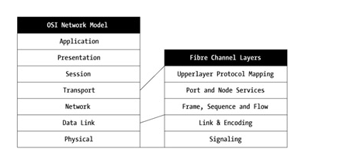
Figure 1-10: Fibre Channel layers mapped to the OSI reference model
Although there are many providers of HBAs, the market for Fibre Channel HBAs is dominated by Emulex (45 percent of the market in 2002) and QLogic (30.8 percent of the 2002 market). As you'll see in subsequent chapters, there is a great deal of partnering in the industry. Storage network vendors try to build interoperable solutions while contributing as much value and extracting as much margin as they can. Contracting out to other manufacturers is commonplace, and places an additional burden on interoperability as products incorporate complex components to achieve higher performance.

Putting Together the Hardware Puzzle
You've now seen all of the major concepts involved in moving data around inside a server. The bus architecture has significant drawbacks when it comes to managing transfers of large amounts of data. The solution to this problem comes to us from the telephony side of technology in the form of switches. This technology grew out of the need to connect many different callers across the country and around the world, with high quality and reliability—much higher, in fact, than computer users have demanded until recently.
Moving the processing out from the CPU to the controller card is an effective way of gaining performance efficiencies. The data no longer has to traipse through the server as part of being handled, unless that data has been requested specifically by the server OS for some particular application task.
This principle goes further with Network Attached Storage and Storage Area Networks. In an NAS environment, the buffering, caching, and physical I/O to disk is handled by a dedicated, optimized appliance, with little or no impact on the host bus adapter.

Topologies
Regardless of which HBA you decide is right for you, the topology of your SAN is the next consideration. The two options are point-to-point or switched. Both Fibre Channel and Gigabit Ethernet support either, but Fibre Channel supports an additional topology called arbitrated loop. These topologies are shown in Figures 1-11, 1-12, and 1-13.
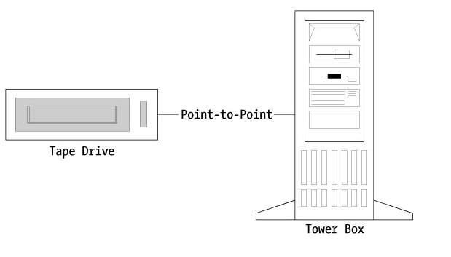
Figure 1-11: Point-to-point storage network topology
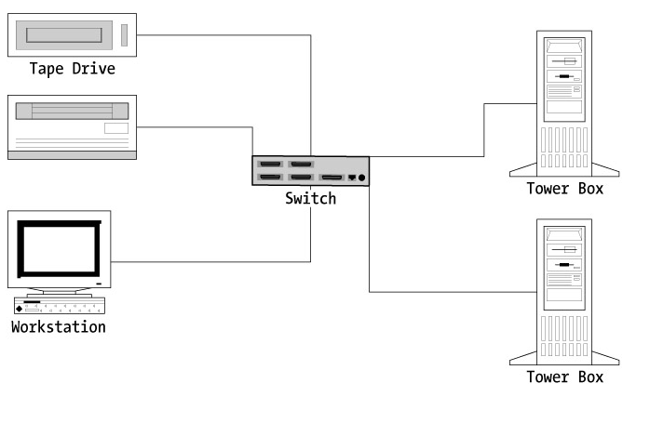
Figure 1-12: Switched storage network topology
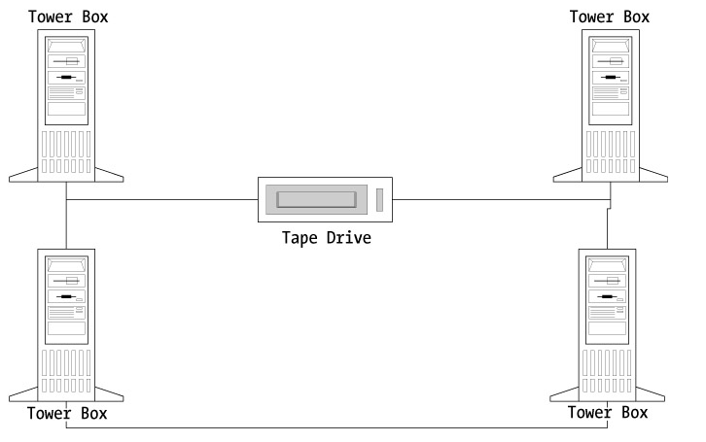
Figure 1-13: An arbitrated loop topology in a Fibre Channel implementation
In Figure 1-11, you can see how a storage device and server connect in a point-to-point network. Another example of a typical point-to-point topology connects a server and an offline storage device such as a tape drive (see Figure 1-12).
The switch allows multiple devices to interconnect dynamically, as shown in Figure 1-13.
All devices on the loop share the same throughput capacity.
I go into technical detail on topologies in Chapter 3. However, it seems that it might be a good idea to at least generally introduce how these networks function from the perspective of options and implications.
Those of us who grew up in the "Duck and Cover" era no doubt remember the famous red phone linking the White House and the Kremlin. This is to me the classic point-to-point dedicated link. Always there, always ready, never any interruptions. However, I've been told that one of the biggest problems with being old enough to have 20-plus years' experience working with computers is that one (I won't say I) sometimes has difficulty being relevant to the younger generation. For those of you who don't remember Duck and Cover, ask your grandfathers about those "Fall Out" shelter signs. Really, it's fascinating.
Instead, let's look at the Dark Ages of the Internet, when people actually used dial-up lines. The network in this case is the phone system. When you dialed up your Internet service provider, you established a point-to-point link. But because it wasn't always on, it wasn't dedicated. If while connected to the Internet you established a chat session with several people, you could consider that a loop. The capability of the line was shared or arbitrated across the connected parties depending on who was typing and who was reading. Using the same phone to make a call is like a switched network. You can get to any address anywhere, be forwarded or put on hold, and leave voicemail at any number—unlike dialing your ISP, which was your telephone number always connecting to the ISP's telephone number.
To extend the metaphor, consider that the phone in your house is like a bus topology. If you pick up the phone and someone else is on the line, you are in contention for the service. "Get off the phone, I need to make an important call" is an example of contention arbitration by priority.
Like any technology, every combination has its features and benefits. One of the main themes of this book is matching the capabilities and costs of storage networks to your particular set of requirements.

Networked Storage: NAS is SAN Spelled Backwards
Network Attached Storage has been described by some vendors as file oriented: Ethernet-based general storage that can be quickly and easily installed. SAN technology deals more effectively with block-oriented I/O characteristic of database access and online transactions. I believe that with the introduction of iSCSI over both Fibre and Gigabit Ethernet, and perhaps even more important, the introduction of SAN file systems, a more practical differentiation is whether a SAN is segregated or not segregated.
Segregation in this case is the extent to which your storage network is accessible to clients and servers, resulting in shared network traffic. By that definition, a NAS is any storage network configuration where the assets are directly addressable. A SAN, conversely, is formally segregated, and intelligence is deployed in the arrays, switches, and routers to isolate and secure the storage devices.
This isn't to imply that a NAS configuration is insecure (although it may be) or that a SAN solution isn't easily accessed (although it too may be). The purpose of this rule of thumb description is to help clarify the convergence of Fibre Channel and Ethernet technologies as well as copper and fiber-optic cabling media. You can consolidate your direct-attached storage into a wide variety of alternatives. The point I'm making here is that traditional NAS/SAN distinctions are less about the technologies employed and more about the topologies deployed.
As I'll cover in Chapter 12, the business case for SAN technology doesn't have to revolve around many servers accessing hordes of disk. You can just as effectively design and build a storage network as a way of building a high-performance disk subsystem for an imaging, database, or message store application such as Microsoft Exchange or Lotus Domino. One key advantage in that scenario would be the ability to add in shared backup services without affecting server performance.
In both cases, I'm describing networked storage. What I really want to do is to make it easier for you to understand what storage networks are, how they work, and what they can do for you. As a starting point, let's assume the TLA (or three-letter acronym) NAS translates to a nonsegregated storage network and that SAN refers to a segregated storage network. These topologies are compared later in Figure 1-14.
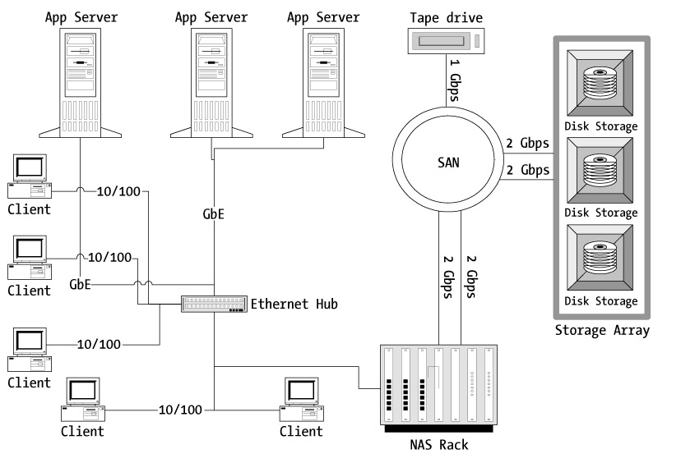
Figure 1-14: A typical NAS gateway configuration including GbE and SAN technologies
One of the promises from storage vendors is that they can be in and out, with the NAS up and running, in about an hour. This implies they either have a truly terrific training program or the technology is more straightforward than we typically think of with a SAN.
Offerings such as HP's StorageWorks NAS 1000s is a Windows-powered appliance that supports both CIFS for Microsoft clients and NFS for Unix. Basic features include snapshot backup, replication, and volume expansion services.
NAS implementations are tied into the production LAN, and they contribute to the volume of activity on the network, which, like any additional contention, can affect performance.

SAN—Switched Network Storage
In return for the cost of complexity and higher sticker price, a SAN moves the network traffic away from the production network, while still providing access to data stores to multiple servers and their clients. This is accomplished with switching technology.
In a SAN, another term for these interconnected switches is the fabric.
Fibre Channel switches are designed to be self-configuring. When a device, such as an HBA or storage array, is connected to a fabric, it's assigned a unique 24-bit address. As more switches are added, addressing conflicts can occur, and this adds to the implementation complexity that has been traditionally associated with a SAN over a NAS.
The key benefit is the ability for any given server to access any given data store via the fabric. Add to this the ability to extend the distances between switches outside the local area, and to administer all of the devices in the storage subsystem from a single console.
The frontrunners for fabric technology include Brocade and McData. These two companies drive standards and have partners who incorporate their switches into overall solutions.

NAS Gateway
One of the latest additions to the SAN and NAS landscape, this type of gateway provides IP connectivity and file system services to servers, while taking advantage of SAN resources and management software behind the scenes. The IP connectivity allows servers or clients to take advantage of Fibre Channel-based storage without being directly connected via a Fibre Channel HBA.
A configuration combining NAS and SAN resource access through a NAS gateway is depicted in Figure 1-14.

Writing to Disk
You should be somewhat comfortable with the high-level treatment of HBAs and switches, NAS and SAN configurations, and the role of the protocol in moving bits from the server through the network. At some point, the file or the transaction must be physically written out to an electromechanical disk or another kind of stable storage device.
Like the sections on host bus adapters and fabrics, I would like to point out that there is a different set of vendors who dominate the market for the provision of storage devices. And like the considerations surrounding the choice of adapter, there is an equally diverse array of options for disks.
A few short years ago, interoperability between different vendors of storage devices at the operational level, complete with integration of switches and adapters from a different set of vendors, was more wishful thinking than practical. As networked storage capacity has surpassed shipments of server-attached disks, the commitment to certifying multiple vendors has become more of an action item.
As much as you might like to design a storage network that assumes disk is a commodity—as in JBOD (short for "Just a Bunch Of Disks"), real-world compatibility issues are a very real threat. Ongoing upgradeability of firmware versions, introduction of new servers and software—all of these very real operational requirements mitigate away from best-of-breed buying towards a "known-good-configuration" orientation. I'll identify those certified product sets as we progress through the book.
There are several key offerings that need to be introduced as part of the component descriptions for networked storage. These include storage offerings from market leaders EMC, Hitachi, and HP. As a result of my own experience, I'll add in some description of the IBM Shark and Storage Tank equipment as well in Chapter 2.

A Word on Disks
In the same way that I spent a certain amount of time reviewing the behavior of buses and adapter cards, I think it's appropriate to review the few major disk technologies from the ground up. These include SCSI, ATA, and serial ATA.

ATA Disk Drives
I would imagine that pretty much every reader of this book has, in one incarnation or another, installed a hard disk on a system. Those IDE drives incorporated the parallel ATA technology. Serial ATA is quickly pushing these drives to the side, especially for networked storage. In this world, Seagate and Maxtor are the first companies to deliver serial ATA drives, with Western Digital playing catch-up. (Or leapfrog if you prefer.)
Disk drives are electromechanical devices comprised of platters that spin, for purposes of this discussion, at speeds of 7200 revolutions per minute (rpm), and heads positioned over the platters that seek locations with an average access time of 9 milliseconds.
The Serial ATA interface is capable of a top short burst of bandwidth of 150 MBps, whereas the older ATA/100 technology maxes out at 100 MBps.
Serial ATA drives, priced lower and for somewhat less demanding applications than the transactional block I/O found in SANS, tend to be used for online backup, image storage, and NAS configurations. Some controllers support a mix of ATA and SCSI drives.

SCSI
Traditionally, SCSI drives were the big capacity, high-performance drives on the market. In 2002, ATA took the lead in storage capacity per drive. Now the various offerings compete on price/performance and warranty/reliability features. From a performance standpoint, Fujitsu offers a 15,000 rpm rotational speed that reduces average seek time to 3.3 milliseconds. These Ultra320 SCSI drives allow transfer rates of up to 320 MBps, with internal transfer rates rated at 118.2 MBps. The external transfer rate refers to the speed at which bits are moved after they come off the platter. A more telling indicator is the lower internal transfer rate. As for reliability, SCSI drive manufacturers frequently offer a 5-year warranty, and these drives are priced accordingly.

Connecting the Dots
If you consider the server to be point B and the storage array or disk to be point A, you naturally need a way of connecting the two in order to replace direct-attached storage. As promised earlier in this chapter, here is where I introduce the switch.
But before I can do that, I need to refresh your understanding of how a network functions vis-a-vis that switch. There are considerations regarding switch performance that are just as important as those governing the selection of the right HBA.
When I mentioned my old 10Base-2 Ethernet network and its little black cable, no doubt some of you who are newer to IT thought this was merely nostalgic. In fact, the migration of Ethernet from coaxial cable to twisted-pair cable introduces some concepts that are critical to planning and designing a storage network.
As you may already know, Ethernet is a broadcast-based protocol. It sends out addressed collections of bits (datagrams), and these are picked up and processed by the addressee. The original design of Ethernet was along this long black cable in a bus topology. (And yes, this is the same bus configuration that figures in my discussion of server internals.)
The problem, very quickly experienced by those of us who had to "fish" cable along conduit, was that as more stations were added, performance dropped considerably. Ethernet devices could only transmit when the coast was clear—the Carrier Sense, Multiple Access part of CSMA/CD.
Along came 10Base-T with its twisted-pair cable, which among other things meant we could have the wires from each workstation go directly to the wiring closet or computer room instead of meandering around the ceiling.
The central device in this topology was the hub, also known as a port concentrator. The point I want to make here is that a hub/concentrator is not a switch or router. By using switches or routers, you may do away with the need for a hub, but the internal processing and that impact on performance is directly relevant to understanding a storage network.
Ethernet by specification is half duplex. It listens and transmits on the same channel, and from a CSMA/CD standpoint this means the coast must be clear in each direction. To extend the expressway analogy, every big city I've ever driven through has at least one of those hated exits that is also the entrance for other cars. This works fine as long as traffic is light, but during rush hour, it can be nerve-wracking to get into the far right lane just as someone else barreling along at 75 miles per hour (I drive on the LBJ in Dallas) wants to occupy the same space you do on the left before they run out of lane.
Twisted-pair cable took care of this by segregating the transmit and receive signals on specific wires. If nothing else, 10Base-T allowed for a more civilized exit and entrance for packets and reduced contention, thereby increasing overall network performance.
But wait, these packets worked (and still do) in a broadcast mode. This means that although they don't need to run from one end of the coaxial cable to other, pushing off the terminator like a swimmer hitting the end of the pool, they need to be propagated from the concentrator out to the other attached devices.
The highest point of contention then moved from packets through the wire to activity in the hub. These hubs worked as store and forward repeaters. The signals went from the sending device to the hub where a copy was made, and the signal boosted and sent out on the receive line to all the other connected devices. The hub would retransmit if a collision occurred, and once successfully received, an acknowledgment was sent back to the hub and the buffer cleared of those packets.
A switch does something quite different. A switch maintains an address pool, and it does the work of identifying the port to which the address is connected. In this way, a switch manages the interconnection of significantly more devices, and the efficient throughput of traffic, by taking back the work that had been previously downloaded to the adapter cards.
A switch works at layer 2 of the ISO model; it more or less dumbly moves the packets from point to point. A router on the other hand handles packets at network layer 3, which allows it to provide additional services such as filtering and translation from one link type to another. A common example of a router is found in a basic home network with the PCs connected via a built-in 10/100 switch or wireless link and the ADSL modem connected in the uplink port. When a participant on the Ethernet accesses the Internet, the packets are translated from the subscriber link and the modem to the Ethernet hub, and for 10/100 wired clients, the address is directed by the switch to the correct port. Wireless clients are handled by the broadcast nature of wireless in a manner like a hub. The transmitted packets are sent to all stations for rejection by the wireless cards if not for them and receipt by the addressee.
I like this hybrid example as it shows the roles of routers, switches, and hubs, as well as points us in the direction of where bottlenecks can occur.
There is a place for both hubs and switches in various Ethernet topologies, depending on the application. If you think of the behavior of a NAS as being similar to a hub-based network implementation and the SAN as incorporating switched functionality, you see the reason why it's important to understand the bus versus star, switched versus concentrated topologies.
The inexpensive routers are appropriate and popular for home and small office environments. But as experience has shown, they aren't scalable beyond a certain point given their broadcasting to all stations. For scalability, a switching technology is required.
Switches themselves, as a class, might be the right answer when planning a storage network, but all switches aren't created equal. The cornerstone value proposition of the switch is the ability to provide full throughput for each port, even as the number of ports in use climbs.
This means that internally, the switch must be able to receive a stream of packets at, say, a 100Base-T, and write them out at the 1000Base-T speed of the server, even while managing the handling of incoming and outgoing datagrams from other ports, and simultaneously looking up the addresses in its address table.
The capacity of the switch is affected by its internal design, which includes a backplane. As I show you different switch offerings and capabilities, you'll see that these differences in architecture affect scalability and performance, just as they do in a workstation or server.

Switch Technology
Switch technology is used in Ethernet and Fibre Channel networks. A switch is a box with ports to which cables are connected. Logic is held in an Application-Specific Integrated Circuit (ASIC) in order to maximize the throughput of the bits from one port to another. A switch has a backplane along which it moves these bits from port to port.
However, the throughput of any given switch is governed by more than the number of ports times the speed supported by each port. Unlike a hub, switches don't broadcast; they instead inspect the address of the packet and send it to the appropriate port.
Moving the inspection and forwarding logic onto a chip, the ASIC greatly increases the efficiency of the switch. Offloading the processing from a CPU once again proves its value. The type of inspection and ways in which forwarding is determined can be related back to the OSI model.

Layer 2 Switches
As I identified earlier, layer 2 in the OSI model is where the data link occurs. In Ethernet, this is where the Media Access Control (MAC) address of the recipient is used to match to a port. For more than 15 years, Ethernet device manufacturers have been building cards with unique addresses—the MAC address. The green data link light on a switch indicates that the MAC address has been successfully added to a table in the switch. A Fibre Channel fabric uses a similar addressing scheme so the behavior of the two types of switches is consistent with this description.

Layer 3 Switches
Layer 3 switches calculate the route to send packets along based on the logical address assigned to the data packet. An IP address would be an example of a logical address. This becomes significant as subnets and internetwork connections become more complex with larger numbers of devices. A traditional router also performs this service, but does so in software, which tends to result in slower throughput.

Layer 4 Switches
This kind of switch relies on the IP from the layer below it, but adds flow control and reliable delivery through the usage of protocols such as TCP and UDP. By looking at the port number, as well as the IP address, routing decisions can be taken on the type of service. Web pages requested for port 80, for example, might be best stored on a NAS file system where a relational database port could be directed to a block I/O device on a SAN. Prioritization is another service that may be beneficial—web pages for browsing might be a distant third priority when contending with a database query for a patient record, for example.

Comparing Switch Layers: Performance and Service
The lower the layer, the closer the logic is to the hardware, and the result is faster throughput, which means more ports capable of higher sustained rates of transfer. As switches have evolved, more intelligence has been put into the ASICs, resulting in layer 3 switches that have the performance characteristics previously obtained only by layer 2 switches.
Layer 4 switches allow for more intelligence in the network—moving past brute-force techniques to enhance network speed. The problem posed by more intelligence is the increase in management skills required to take advantage of that intelligence.
This brings us to the next major feature of a storage network—the software needed to manage and administer it.
As you can see from the discussion on buses and backplanes, the decision of which switch or what HBA to buy isn't a trivial one. Price alone is hardly the way to go about it. But like server technology generally, the cost isn't simply the sticker price on the gear. There is also the amount of time that must be invested in the care and feeding of any network—and storage networks intensify this requirement.

Orchestrating the Arrangement
The management of these complex devices and interconnections can be summed up in a five-point list:
- Storage resource management (SRM)
- Storage network management
- Policy management
- Data management
- Virtualization
Let's take a closer look at these areas of management.

Storage Device and Network Resource Management
This is essentially product management, where the products are the disk arrays, network appliances, and tape libraries. A wide range of tools is available to give an administrator insight into the utilization of storage assets. Job monitoring and notification as well as reporting are key elements of SRM.
Managing the network is generally a discrete SRM function, with specific attention paid to network utilization, identifying bottlenecks, and optimizing resources in place, as well as helping plan for upgrades as driven by demand.

Data and Policy Management
These tools enforce decisions that govern the amount of data users can store, and how it will be grouped and accessed as well as protected. Latency in delivering data is a key factor for containing storage costs, and policy management automates the process of moving data into less costly storage. Recoverability requirements are defined as part of the data management practice, and these thresholds trigger policies for data groups.

Virtualization
Virtualization is to storage networks what Logical Volume Management (LVM) is to server-attached storage. It's a way to declare and modify disk resources to servers without handling everything at the physical level. Early in my career as a database administrator, I had to physically carve up raw disk partitions, declare them to the database engine with their slash-dev address, and decide specifically which ones to mirror. When LVM showed up in HP-UX, I was amazed at how much easier my job was. This meant I could administer more servers in the same amount of time, and therein is the value proposition of virtualization. The same number of administrators can manage an ever-expanding network of connections and devices.
John Cordelis, Total Storage Manager for IBM Canada, says, "What we want to see administrators do is use Storage Tank, install volumes on every server at their maximum size, say 2 terabytes. Then, as they use it, they can simply add more devices to the Tank without having to reconfigure their volumes server side."
Other vendors have similar ideas. HP, EMC, and Network Appliance all offer storage virtualization at the disk or hardware level. VERITAS has a virtualization offering at the host level.
A storage network is almost never from a single vendor; it's made up of components from a number of providers. The overall solution must fit the unique requirements of each site while conforming to the general standards in order to interoperate. It's a fine line and a great deal to expect. The concepts that I've introduced in this chapter will help you design a storage network that is optimized for the kinds of usage you expect, and allow you to tailor that design as your needs change.

Summary
For some, this chapter will have been a straightforward review of standards and products involved in different networked storage solutions. For others, the comparison of Fibre Channel and Ethernet in the context of OSI layers may be a new way to sort out the different components and their behavior.
How bits move within a computer and across a network are the key elements that any storage network designer or administrator has to understand. Contention makes for bottlenecks that affect performance, and the need to integrate software, hardware, and services from many vendors introduces complexity—which is difficult to manage. Virtualization is turning many of the products into logical resources that can be more easily administered, after the installation is designed and the equipment acquired.
"From the ground up" implies that we appreciate the importance of the things we plug in to make up a storage network. From this chapter, you should be able to more easily segregate fiber from copper, Ethernet from SCSI, and Network Attached Storage from a Storage Area Network.
The cornerstone concepts to take from this chapter relate to the digital data transfer rate (aka bandwidth) and how it's calculated. Theoretical throughput is theoretically interesting. From this chapter, you should have a better sense of how to measure the capacity of each link in the storage subsystem chain and evaluate its impact on your data stores.
The network is indeed the computer, and the move to storage networks is an evolutionary step in enterprise computing. In this chapter, I've clarified a potentially bewildering array of products and terms. At this point, you should be ready to move on to the next level of detail.

Chapter 6: File Systems and Network Protocols

Overview
File system sharing protocols typically operate at layer 6 and 7 of the OSI model. The presentation and management of file or data interchange is built on top of the physical, datalink, transport, network, and session services already established for a given set of servers. In this chapter, I'll discuss two of the commonly found file sharing mechanisms, Network File System (NFS) and Server Message Block (SMB)/ Common Internet File System (CIFS), as well as the way in which the two of them leverage lower layers of the networking stack.
Support for multiple communications protocols and file systems is a commonly found feature in many NAS appliances. From this chapter, you'll get a grounding in the specific behavioral characteristics and limitations of the common protocol and file system families. I'll cover this by reviewing a typical configuration from a direct-attached storage standpoint, using that straightforward example to pull out the details relevant to a storage network.
Security and administrative considerations will be identified here and covered in more detail during the chapters dedicated to those subjects. From this chapter, you should gain an appreciation for the way a given file system is associated with a family of supporting standards, protocols, and products.
The "continuum of complexity" represented by file systems and the activities they facilitate is described in this chapter. After reading it, you should be aware of the architectural differences between a dedicated OS file system and that which could support a storage network.

What is a File System?
As you saw in Chapter 2 during the discussion of hard disk technology, the devices themselves are quite dumb. Disk drives rely on block addresses to read and write data. The format for interpreting the data and the services for relating file names, directories, encryption, and permissions is handled by the file system.
Block devices read and write data in blocks to specific locations on the disk. Blocks are groups of bytes in the structure determined by the file system when the device was formatted. During the read and write operation, the block addresses are used to locate, write, or retrieve data on the disk. It's the file system that converts these blocks into files and other data resources.
A character device writes streams of bytes to the disk sequentially. For the purposes of this text, the key distinction between a character device and a block device is the role of the operating system in handling the data resources. File systems using block devices will typically cache data in memory to assist in the handling process. For certain types of applications, such as transactions using a relational database, this introduces a potential risk to data integrity. In situations where an application has marked a transaction complete, but the data hasn't physically been written to disk, that transaction might be lost in the event of a systems crash. It's for this reason that databases are configured with raw or character devices rather than file system resources.
The file system used is generally a function of the operating system. Windows systems, for example, have used FAT, FAT16, FAT32, and NTFS to identify the relationship between blocks and file resources. The file allocation table (FAT) resides on the disk and is read by the operating system to determine the contents, addresses, and permissions associated with each file entry. It associates the logical file resource descriptions with the physical blocks that make up the file as stored on the hard disk. Additionally, the file system maintains lists of available blocks and allocates new blocks to files as they grow. Conversely, the blocks belonging to deleted files are marked for return to the available pool.
This is, of course, a simplistic treatment of what a file system does. As more users join the system, contention must be managed. File permissions are an attribute of the data resource, but there is a considerable amount of range in the security services provided by different file systems.

Shared File Systems
A file server is one implementation of a shared file system. In this case, only the file server has physical access to the devices. Other systems become clients of the shared file system and support updating of local copies of file resource caches. This common topology for file sharing is the heart of the NAS product architecture.
Although there are several experimental and other proprietary special-purpose file systems, in this section, I'll examine the most commonly found. From the standpoint of networked storage, your file system of choice will need certain characteristics, including the following:
- Distributed support: The file system must allow access to resources across the network.
- Client support: The protocol for accessing the file system must be readily available on a number of client/server platforms.
- Authentication: The ability to secure access based on established permissions.
- Administration: As the number of file systems and clients increases, effective administration utilities become more important.

Network File System
Developed by Sun Microsystems in the mid 1980s, the Network File System is a shared file system that allows users on the other side of the network to mount a set of file resources and access them under an authentication scheme. This is implemented through shares exposed through an application programming interface to a client. File systems belonging to one server are cross-mounted over the network. The remote host processes calls for file services to or from that resource.
In either case, the NFS services are implemented via remote procedure calls (RPCs). These calls invoke the file find, read, or write procedures on the NFS server and return the file resource to the calling client. RPCs are combined with external data representation (XDR) to isolate the programmer from the network communications specifics. Figure 6-1 depicts the stack of services for NFS.
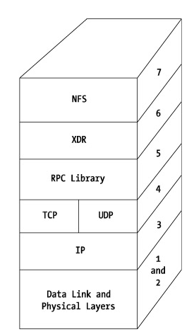
Figure 6-1: The NFS stack
The NFS API supports the following requests:
- Read-only: mount, getattr, lookup, readdir, read, readlink, statfs
- Tree modifications: mkdir, link, symlink, rename, unlink, rmdir
- File modifications: setattr, write
Authentication is user based, where the user ID is communicated with the RPC to the server for validation.
It's worth noting that NFS is similar to SMB in that both are a connectionoriented session layer service, requiring access to underlying network protocols in order to function. Performance is constrained in both by network configuration and the performance profiles of the network components. NFS is usually implemented over the TCP/IP communications stack.
The TCP/IP protocol suite also supports UDP. TCP is a guaranteed delivery protocol, meaning the packets are checked and re-sent if corrupted or missed. This naturally requires some processing overhead. User Datagram Protocol (UDP), on the other hand, isn't guaranteed to deliver its packets, nor are the packets sorted. They are streamed from one network device to the other.
Depending on your network topology and traffic, you may decide to opt for either UDP or TCP as the basis for your NFS network.

Network Information Services
Originally referred to as "Yellow Pages," the Network Information Services (NIS) is used as a mechanism for managing NFS mounts and user access profiles. To allow a client to connect to any machine with an NFS-mountable volume, the participating machines use NIS to synchronize the user name and password, home directory, and group information. As complex associations are built up, synchronization of NIS password files can become problematic.

Server Message Block
The most commonly found cross-system protocol for file systems and other resources is the Server Message Block protocol—SMB. Installed as part of all Microsoft-based systems since Windows 95, SMB is clearly the most prevalent file and resource-sharing protocol in terms of seats. Support for client systems includes Samba, which runs on Linux and other Unix variants and is available for Mac OS X since version 10.2.
Microsoft released a specification for SMB into the public domain called CIFS, short for Common Internet File System, which runs only over TCP/IP. SMB itself supports a wide variety of networking protocols.
SMB (and CIFS) are client/server request/response protocols in which messages are exchanged between connected systems. The resources that can be accessed under SMB include files, of course, but clients may also make requests of named pipes, APIs that support SMB, printers, and mail slots. In other words, the messages exchanged between an SMB client and server aren't limited to disk access.
As a connection-oriented protocol, SMB packets are exchanged through a virtual circuit established between the client and the server. On initiation of the SMB session, a virtual circuit is established and session user ID created along with a resource connection tree ID (tid) and file identifier. In the event that the link between the two systems is invalidated, any file handles that were previously set up are also invalidated, and the connection must be rebuilt completely.
Authentication occurs at two levels—Share and User. The Share level places a password on a shared device, and as long as the client passes the password to the SMB server, that share will be made available. This is so common as part of Windows-based networking as to be highly intuitive. User-level authentication allows the segregation of permissions for specific files on a network to specific users. The SMB client submits a UID along with requests to the server, and that UID is parsed for appropriate permission.
SMB servers broadcast their existence to clients through a browsing mechanism, and clients build up browse lists. In spite of the apparent ease of access through these browsing mechanisms, there is a performance impact on file transfers under SMB, depending on the application used to make the connection.
There are two modes available for SMB file transfers: raw and core. Raw mode typically uses 60- to 64K file blocks, whereas core mode transfers occur using a 4- to 16K block size. This makes raw mode performance higher than core mode transfers.
When connecting to a Windows-based SMB server using Explorer in order to move a file to a remote computer, the virtual circuit doesn't grant exclusive access to the command, and the transfer occurs in core mode. Conversely, when the move or copy command is issued locally, as when the file is pulled rather than pushed, raw mode is used and the transfer rate is higher. Raw mode is invoked in both directions using an MS-DOS command prompt.

SMB Protocol Stack
Samba is built on top of the NetBIOS network protocol, which in turn may be installed on TCP/IP, IPX/SPX, Token Ring, and other more obscure offerings. The behavior of SMB is greatly affected by the characteristics of the underlying network protocols that support it. Although this principle holds true for every file system potentially used to share file resources over the network, SMB/CIFS is interesting for two reasons: its modest beginnings as a very small networking protocol, and its ultimate domination as the most prevalent client/server resource-sharing service. This is due to its inclusion with all Microsoft-enabled PCs from Windows 95 onwards.
Originally, NetBIOS provided session services with network and transport services provided by NetBEUI. Given that NetBEUI is unrouteable, meaning NetBEUI packets can't cross a bridge when they come to it, another means of providing network services was adopted. This gave rise to NetBIOS over TCP/IP (NBT). For these implementations, TCP/IP handles the addressing of SMB servers.

Standard Name Resolution
For systems where TCP/IP is the standard networking technology, such as Unix systems, SMB servers are located in the following order:
- Local hostname
- Host file lookup
- Domain Naming Services (DNS)
- NetBIOS name resolution
This is also the technique used by Windows 2000 and later systems from Microsoft.
There are three other means of resolving addresses of NBT hosts within a Windows network. The name cache contains the name to address entries for NetBIOS servers. The cache is populated from either successful name resolution requests or through preloading the LMHosts file.
Inside the LAN a broadcast is sent requesting the IP address for a server name. This NameQuery packet is sent to UDP port 137 on all computers on the local network. If the host is unavailable, there is no response, and the request is unfilled. Otherwise, the IP address is returned to the requestor, and a connection established. Broadcasting can quickly build up on a large network and is the default mechanism for Windows-based resources where a WINS server isn't configured. While the broadcast is limited to the local subnet, it does require handling of the packet by all machines on the network, not just the system providing the share.

WINS
Germane to Windows NT 4 environments, WINS uses DNS in all later environments.

LMHosts
LMHosts is similar to the hosts file on a Unix server. It's a maintained list of server names and addresses. The roots of NetBIOS in small LAN environments can be seen in these kinds of administrative artifacts. A small list of server resources, maintained in a contained geography, could use this approach, as systems and services grow; however, the administrative overhead incurred this way can become onerous.

SMB Administration
As an SMB implementation, Samba shows its roots in small networks in the lack of availability of in-depth administrative tools. In contrast, the Domain Controller model in Windows NT 4 was used similarly to NIS for the authentication of large numbers of users supporting centralized control of their access to file and print resources. With the introduction of Active Directory

Journaling File Systems
Like many of the more advanced file system features, journaling was introduced in the mainframe data centers where bringing a system back online quickly after a reboot was a driving requirement. It's important to keep in mind that RAID protects only against disk failure. In the event that a transaction or command corrupts the file system, the RAID mirrors or parity disks will faithfully duplicate this corruption.
When the data is restored and the system restarted, large data centers found they didn't much enjoy waiting for a file systems check to be completed before the production application could be put back in business. This gave rise to journaling file systems.
Similar to the way RAID keeps a record of changes made to a disk so the image can be re-created in the event of a failure, a journaling file system keeps a journal of changes at the file system level. Examples of journaling file systems include the Ext3 disk format found in Red Hat Linux. Other examples include JFS, XFS, and Elvis, the journaling extension to the HFS file system for the Mac OS X.
For Linux, there are several of these available, including
- ReiserFS
- XFS
- JFS
- Ext3
In each case, the file system keeps track of changes made to file system resources as a transaction. File system metadata might include inode numbers used or directory entries. Under a journaling file system, the intended changes to the file system are recorded in advance in the journal. The changes are made and the completion of the transaction duly noted in the journal. For those of you with database experience, yes, this is a log for file systems very much like a database server.
Similarly, the log or journal is applied to the file system in the event of a recovery from a crash. The state of the file system is restored to consistency by reviewing the journal and applying those changes successfully completed. The changes are effectively replayed or performed again or rolled back depending on their state.
Let's take a look at the journaling file systems supported by the Linux 2.4 kernel. I don't advocate one over another without a solid understanding of the context and requirements. They are presented here to help introduce you to some of the available alternatives.
- ReiserFS: ReiserFS version 3 was released as the first journaling file system for Linux. It's the default file system for SuSE, Lindows, and Gentoo. Reiser4 is based on Linux kernel 2.6 and focuses on large file system performance. It incorporates a plug-in architecture to support inclusion of third-party extensions developed for the ReiserFS environment. ReiserFS has demonstrated very high performance with smaller file systems.
- XFS: First developed by Silicon Graphics Inc. for their IRIX OS, XFS has been made available under a GPL for Linux developers. XFS can be installed on top of the Logical Volume Manager. It has been built into several Linux distributions including Mandrake, SuSE, Gentoo, Slackware, and JB Linux. Support for large directories and user quotas is included in XFS.
- JFS: Developed by IBM, the JFS is offered as open source under a GNU General Public License. Distributions that support JFS include Debian, Gentoo, Mandrake, Red Hat, Slackware, SuSE, Turbolinux, and United Linux. JFS handles reallocating bad blocks found on disk devices and provides support for SMP servers.
- Ext3: Developed as a journaling version of the Ext2 file system, Ext3 is provided with Red Hat Linux distributions. Resulting from identical underlying structural formats, an Ext2 file system can be mounted as Ext3, effectively converting existing file systems.

Distributed File Systems
Distributed file systems (DFSs) are more than the simple coordination of file access over multiple clients and servers. A robust DFS involves a topology known as clusters, and provides connection management techniques to support cluster members. These services include managing read and write activities, contention and locking, authentication, failovers, and replication.
As the services offered by distributed file systems become more complex, mechanisms for caching and synchronizing data become necessary. This introduces the idea of metadata, which is data about data. This is the point of departure for direct-attached storage, Network File Systems, and enterprise-class storage networks. Metadata managers and transformation services support advanced NAS and SAN features, such as support for concurrent access to identical data resources by heterogeneous clients. Distributed file systems development laid the groundwork for these storage network advances.

Andrew File System
One seminal development for distributed file systems was the Andrew File System (AFS), first developed at Carnegie-Mellon University. Ultimately, AFS became a product owned and sold by Transarc Corporation, a wholly owned subsidiary of IBM. AFS capabilities are relevant as a starting point in understanding the mechanisms that manage a distributed file system generally.
AFS was designed to use a persistent cache on clients for both file and directory data. This cache will survive a restart of either client or server. The AFS cell manages synchronization of cache entries. A cell is a centralized administrative view of a group of AFS servers, exporting file resources as volumes. These volumes can be mounted by clients, but security is handled through authentication tokens rather than on a user profile basis.
This improvement in cache management sets AFS apart from NFS and SMB.

DCE/DFS
Refinements in AFS design concepts were incorporated into the DCE/DFS file system as part of the Open Software Foundation. The reengineering effort resulted in ACLs being defined at the file level, not just directory level, extensions to support other clients (e.g., NFS), and more refined sharing through the token management.
DCE/DFS products have been offered as part of proprietary Unix variants and other hosting environments, and are available for Red Hat and SuSE Linux.

Microsoft Dfs
Through the Distributed file system (Dfs), not to be confused with DFS, Microsoft offers a single tree view for shared volumes provided by different servers on a network. Any user accessing a volume on a Dfs tree need not know the server name where the volume is actually located.

Coda
Coda has its roots in AFS version 2, but offers additional functionality to support replication, disconnection, and reintegration of volumes. While disconnected from a shared volume, Coda logs operations taken on the data when linkages are broken or slow to the point of unusability. The client modification log (CML) records changes to the data and replays those on reintegration with the server. Volume versions are stamped and validated to ensure efficient synchronization.

Intermezzo
An open source project that has its design roots in Coda, Intermezzo is a Linux implementation of a distributed file system supporting disconnection and automatic recovery from network outages. Intermezzo offers support for high availability and mobile computing scenarios.

Lustre
Lustre combines clustering, Linux, and a distributed file system in a public domain offering. Clustering technology is particularly well suited for large systems with high uptime requirements. A cluster, or integrated group of servers, can provide redundancy, load balancing, and high availability with optimum performance. Under Lustre, the cluster is presented as a single systems image, allowing streamlined administration.
Lustre is a departure from traditional clustered file systems. Clusters typically share block storage across devices managed by a metadata server or distributed metadata updates. The model for Lustre is an object-based distributed file system (ODBFS), which defines storage objects that are manipulated by controllers. The command set in the object interface supports more than a mapping of names to block addresses. Depending on the implementation of the object driver, RAID, parallel write, or cryptographic encryption could be supported.

Sistina Global File System
The Global File System (GFS) shared file system for Linux is a commercial offering from Sistina for Red Hat and SuSE. Designed to support distributed database and web application servers by providing a single, common view of shared data, GFS incorporates both distributed metadata and multiple journaling techniques. Several locking

Enterprise Volume Management Systems
Building on the discussion of volume management and file systems, I want to introduce you now to the Enterprise Volume Management Systems (EVMS). EVMS provides a storage management environment that includes support for bad block allocation, linear drive linking, and generic snapshots.
Perhaps the most interesting thing about EVMS is its ability to support a wide range of file systems on a number of platforms. The supported file systems are as follows:
- Ext2
- Ext3
- ReiserFS
- XFS
- Swap
The existing storage platforms on which EVMS can be operated include
- BSD
- Macintosh
- Linux MD/Software RAID
- Linux LVM volume groups
- AIX LVM volume groups
- OS/2 volume groups
- DOS (FAT) partitions
- GPT disk partitions
- S/390 disk partitions
EVMS can be operated from a command line or through a graphical user interface for use on Gnome and gtk-compliant windowing environments. Support for clustering of private and shared data containers to be administered by EVMS is provided by the Cluster Segment Manager. Through a plug-in architecture, EVMS offers membership and messaging services between cluster nodes and the EVMS engine.
With the introduction of tools like EVMS, you should be able to see the relationship between file systems management and distributed systems. Available in the open source world, these tools demonstrate the capabilities that can be found in turnkey third-party vendor NAS and SAN products.

Summary
NAS appliances offer shared file systems, typically under SMB and NFS connection strategies. From this chapter, you should have a better sense of the underlying functionality and inherent limitations of these venerable file sharing schemes.
Additionally, you should have a much stronger grasp on the relationship between network protocols and the ability for file system resources to be made available to physically separate applications. The introduction of AFS and subsequent distributed file systems should help you visualize the direction that file systems have gone in order to support the exponentially increasing demand for storage across the network.
The role of the file system in brokering data between application programs and lower level storage facilities should be much clearer to you at this point.
Some of the newly offered features in SAN products, like TotalStorage, is the ability to translate underlying file objects into the format required by a connected client. From the discussion of objects under Lustre, you should be acquainted with the levels of abstraction that must be managed to achieve this level of compatibility.
As part of the ground up approach to storage networks, the file systems described in this chapter, as well as the way they support authentication, should give you the foundation for reviewing NAS and SAN security, administration tools, and performance. These are described in the following chapters in the context of specific vendor offerings and customer infrastructure choices.

