Digital Apprenticeships at Gloucestershire College

Infrastructure Technician


Contents
Introduction 3
Qualification 3
Entry Requirements 3
Duration 3
What you will study at college 3
In the Workplace 4
Grading the summative portfolio 4
Progress Monitoring 5
Training plan 5
Appendix 1: Infrastructure Technician Skills Audit 7
Appendix 2: Competency standards 12
The what – what the apprentice has shown they can do 12
The how: the way in which the work has been done 13
The with whom: the personal and interpersonal qualities the apprentice has brought to internal and external relationships 15

Introduction

This handbook contains specific information about the Infrastructure Technician apprenticeship.
See the general handbook for information common to all the digital apprenticeships.
An Infrastructure Technician provides support to internal and external customers, helping them to be productive when using technology to do their own jobs, by using tools to problem solve and trouble shoot non-routine problems. The Infrastructure Technician sets people up on systems and provides support when they need it, rectifying issues to maintain the organisations productivity.
Job roles include:
- Helpdesk Technician
- First or Second Line Support
- IT Infrastructure Technician
- Network Support

Qualification
Level 3 Infrastructure Technician

Entry Requirements
You will need five GCSEs at grades A to C or 4 to 9, (including English, Mathematics and a Technology subject); a relevant Level 2 Apprenticeship; other relevant qualifications and experience; or an aptitude test with a focus on IT skills.

Duration
This apprenticeship will last 18 months in total and will be concluded by an end point assessment (EPA).
It consists of 80% on the job training and 20% of off the job training.

On the job training and projects | 80%
College Day Release | 10%
Assignments/Portfolio | 10%
TOTAL | 100%

What you will study at college
There are five BCS knowledge modules and industry certifications studied in the following order:
CompTIA A+
Microsoft Install and configure Windows 10
BCS Level 3 Award in Cloud Services
BCS Level 3 Award in Coding and Logic
ITIL Foundation

You will be required to complete a module before commencing the next module. Each module has a BCS or professional qualification which needs to be completed by the apprentice. The modules are made up of:
- Technical Competencies
- Technical knowledge and Understanding
- Underpinning Skills, Attitudes and Behaviours

The BCS exams have a pass mark of 65%.
External tests will come in the form of automated tests. The tests offer instant results to the learner. We will provide sample tests on an ongoing basis.
All the topics for each module and industry certification are shown in Appendix 1.

In the Workplace
You will be set projects by your employer and your assessor. These will allow you to show what you can do, the way in which you have done it and the relationships with your colleagues. You will build a portfolio of evidence leading to a final (summative) portfolio for external assessment.
All evidence for the portfolio will be submitted electronically to the college’s electronic assessment software (accessed by web browser)
The purpose of the portfolio is to demonstrate that you have attained all the knowledge and skills shown in this table:
Qualification Level 3 Descriptor
Knowledge descriptor (the holder…) | Has factual, procedural and theoretical knowledge and understanding of a subject or field of work to complete tasks and address problems that while well-defined, may be complex and non-routine. Can interpret and evaluate relevant information and ideas. Is aware of the nature of the area of study or work. Is aware of different perspectives or approaches within the area of study or work.
Skills descriptor (the holder can…) | Identify, select and use appropriate cognitive and practical skills, methods and procedures to address problems that while well- defined, may be complex and non-routine. Use appropriate investigation to inform actions. Review how effective methods and actions have been.

Competency in the workplace, as evidenced by the portfolio, is divided into what you have done, the way in which you did it and with whom you worked. You need to meet the standards to gain a pass, but of you significantly exceed the standards you can be awarded a merit or a distinction. This is decided by the external assessor during end point assessment.
Details of the competency standards assessed in the portfolio are shown in appendix 2.

Grading the summative portfolio

GRADE | The WHAT |  | The HOW |  | With WHOM
GRADE | What you have shown you can do |  | The way in which you have done the work |  | The personal and interpersonal qualities you brought to work relationships
GRADE | Met expectations | Significantly exceeded expectations | Met expectations | Significantly exceeded expectations | Met expectations | Significantly exceeded expectations
DISTINCTION
MERIT
MERIT
PASS

Progress Monitoring

You will regularly be visited by your appointed assessor (normally monthly). Both you and your line manager will be required so that new projects can be agreed
There will be a review of
- your portfolio
- the record of assignment and portfolio time spent away from normal duties
- your progress against expectation
- the projects and tasks to be completed before the next visit
- the date and time of the next visit
All progress will be monitored via the college’s electronic assessment software (accessed by web browser)
The training coordinator will visit you regularly. At this meeting she will evaluate your overall performance, attendance, progress, etc.

Training plan

The table on the next page shows all the activities for the apprenticeship by month.

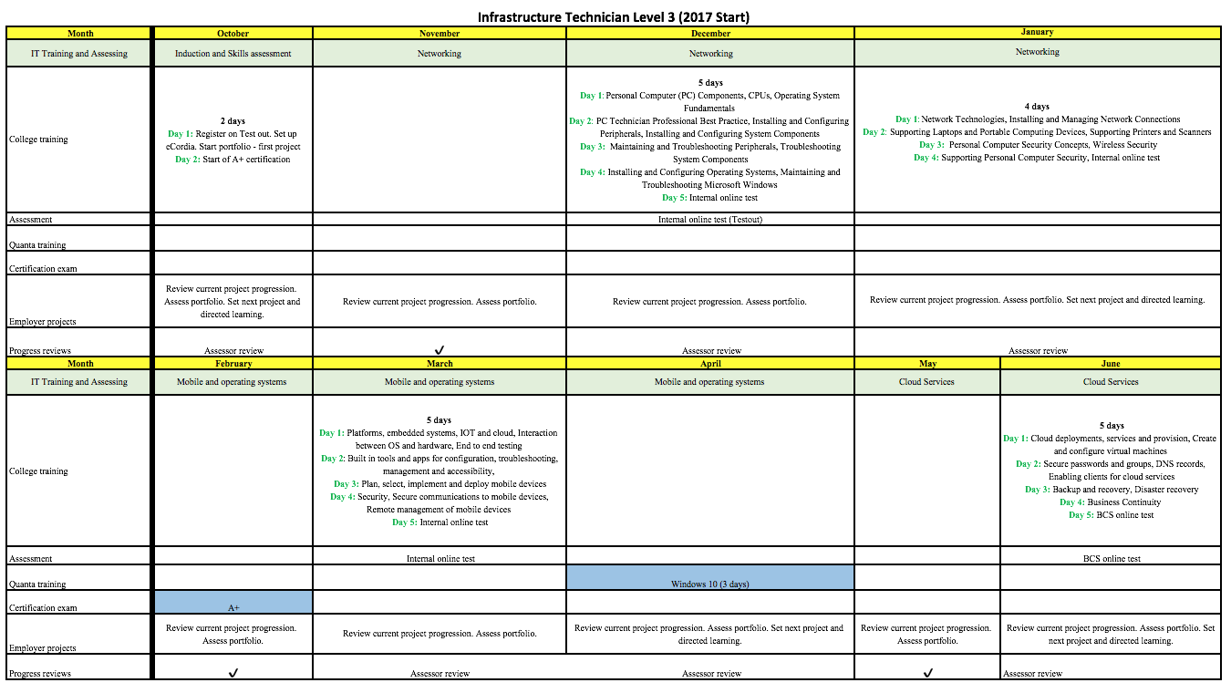

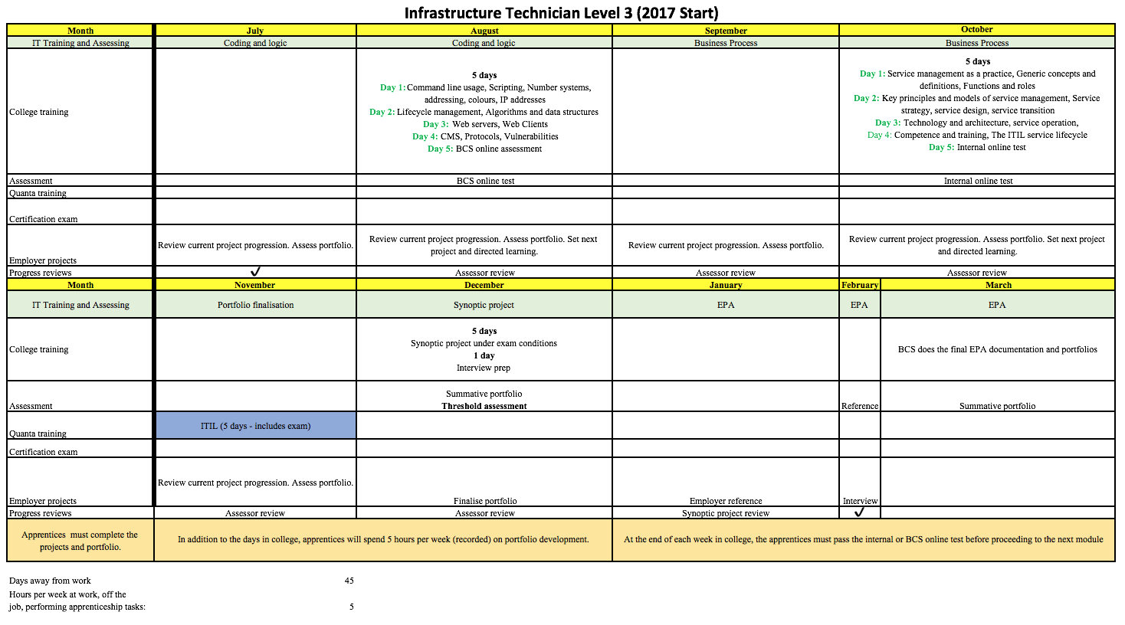

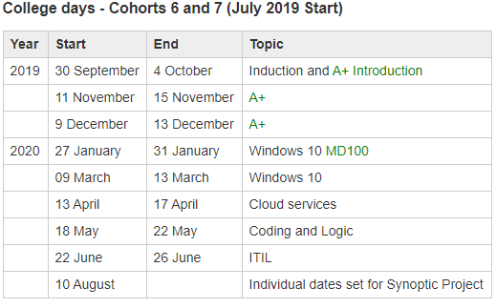

Appendix 1: Infrastructure Technician Skills Audit

The items are from the BCS Knowledge Module (KM) and industry certification curricula. They cover all the topics you are required to know.
Tick the box in each column that most matches your knowledge and competence for that item.
means you do not know this topic
0 means you have some knowledge of the topic
means you are confident about this topic

A+ |  | 0
PC Connection Methods
Create Network Connections
Tools of the Trade
Electrical Safety
Environmental Safety and Materials Handling
Diagnostics and Troubleshooting
Maintaining and Troubleshooting Peripherals
- Display Devices
- Input Devices
- Adapter Cards
- Multimedia Devices
Troubleshooting System Components
- Storage Devices
- Power Supplies
- Memory
- CPUs
- System Boards
Maintain and Troubleshoot Laptops and Portable Devices
Preventative Maintenance, Professionalism and Communication
PC Components, System Unit Components, Storage Devices, Printer and Scanner Technologies, Printer and Scanner Components, Printer and Scanner Processes
Installing and Configuring Peripherals
- Display Devices
- Input Devices
- Adapter Cards
- Multimedia Devices
Installing and Configuring System Components
- Storage Devices
- Power Supplies
- Memory
Laptop and Portable Computing Device Components

Optimising Windows
Installing Microsoft Windows
Install and Configure Web Browsers
Upgrading Windows
Add Devices to Windows
Install and Configure Laptops and Portable Devices
Printer Installation and Configuration
Printer Maintenance and Troubleshooting
PC Operating Systems
Troubleshooting Windows
Recovering Windows
Windows User Interface Components
Windows File System Management
Windows System Management Tools
Maintain and Troubleshoot Network Connections
Operating System Utilities
Maintain Microsoft Windows
Network Concepts
Network Communications
Network Connectivity
Internet Technologies
Install and Configure Security Measures
Maintain and Troubleshoot Security Measures
Security Fundamentals
Security Protection Measures
Data and Physical Security
Wireless Security
Social Engineering
Install and configure Windows 10
Prepare for installation
Install Windows
Configure devices and device drivers
Perform post installation configuration
Implement Windows 10 in an enterprise environment
Configure networking
Configure storage
Configure data access and usage
Implement applications
Configure updates
Monitor Windows
Configure advanced management tools
Configure system and data recovery
Configure authorisation and authentication
Configure remote management

BCS KM3 Cloud services
Cloud deployments, services and provision
Create and configure virtual machines
Secure passwords, groups
DNS records
Enabling clients for cloud services
Backup and recovery
Disaster recovery
Business continuity
BCS KM4 Coding and logic
Command line usage
Scripting
Number systems, addressing, colours, IP addresses
Lifecycle management
Algorithms and data structures
Web servers
Web clients
CMS
Protocols
Vulnerabilities
ITIL Foundation
Service management as a practice
Generic concepts and definitions
Functions and roles
Key principles and models of service management
Service strategy, service design, service transition, service operation
Technology and architecture
Competence and training
The ITIL service lifecycle

Appendix 2: Competency standards

The what – what the apprentice has shown they can do

Competency Standard | Minimum expected requirements
Communication  Works both independently and as part of a team and following the organisations standards; competently demonstrating an ability to communicate both in writing and orally at all levels, using a range of tools and demonstrating strong interpersonal skills and cultural awareness when dealing with colleagues, customers and clients during all tasks. | The apprentice should be able to use a minimum of 3 tools to communicate  - Oral  - Face-to-face  - Remote  - Diagrammatic  The apprentice should be able to demonstrate and compile three different forms of written professional correspondence.  The apprentice must be able to explain 3 types of communication styles to ensure cultural awareness and appropriateness for customers are taken into account.
IT Security  Demonstrates the necessary skills and behaviours to securely operate across all platforms and areas of responsibilities in line with organisational guidance, legislation | The apprentice must demonstrate how they comply with organisational security processes and how they would recognise and escalate issues.  The apprentice must be able to locate and follow policies and legislation
Remote Infrastructure  Effectively operates a range of mobile devices and securely add them to a network in accordance with organisations policies and procedures | The apprentice must demonstrate how to securely connect a minimum of two different types of devices (e.g. laptop/mobile) to access the organisation’s network services (e.g. email, files, applications)
Data  Effectively records, analyses and communicates data at the appropriate level using the organisation’s standard tools and processes and to all stakeholders within the responsibility of the position | The apprentice must be able to select and securely use three appropriate tools when working with and analysing data.
Problem solving  Applies structured techniques to common and non-routine problems, testing methodologies and troubleshooting and analyses problems by selecting the digital appropriate tools and techniques in line with organisation guidance and to obtain the relevant logistical support as required | The apprentice must be able to select and use three appropriate tools for testing, troubleshooting and analysing problems.  The apprentice must be able to demonstrate compliance with organisational guidance.  The apprentice should demonstrate processes and practices for obtaining logistical support.
Workflow management  Works flexibly and demonstrates the ability to work under pressure to progress allocated tasks in accordance with the organisation’s reporting and quality systems | The apprentice must be able to demonstrate the ability to prioritise workflow and manage allocated tasks. The apprentice must be able to record tasks and comply with organisations quality processes.
Health and Safety  Interprets and follows IT legislation to securely and professional work productively in the work environment  Understands and applies Health & Safety policies to every day work | The apprentice must be able to demonstrate their interpretation and secure working practices in accordance with IT legislation.  The apprentice must demonstrate an understanding and apply Health & Safety policies to every day work.
Performance  Optimises the performance of hardware, software and Network Systems and services in line with business requirements | The apprentice must be able to demonstrate how to configure a minimum of three pieces of hardware and configure three different types of software in line with business requirements.
Understands and responds to the correct processes associated with WEEE (the Waste Electrical and Electronic Equipment Directive) | The apprentice must be able to explain how to comply when required with WEEE and the implications of data protection during disposal.

Criteria for a merit or distinction
Dimensions | Description of what significantly above the expected level of quality looks like
Breadth – the range of tools and methods understood and applied | Understands and applies a wide range of tools and methods  Accurately and appropriately applies and effectively implements the right tools and methods in a variety of different situations
Depth – the level to which these  tools and methods are understood and applied | A capable user - exploits the functionality/capability of the tools and methods  Broad understanding of different tools and methods and how and why they can be applied in different contexts
Complexity – the extent and prevalence of inter-related and inter- dependant factors in the work and how well the apprentice has dealt with these | Deals confidently and capably with interrelated and interdependent factors in their work

The how: the way in which the work has been done

Competency Standard | Minimum expected requirements
Apprentices can demonstrate the full range of skills, knowledge and behaviours required to fulfil their job role | Knows what skills, knowledge and behaviours are needed to do the job well  Are aware of their own strengths in the job role, and any areas for improvement Appreciate who else is important, for them to do their job and fulfil the role effectively (e.g. colleagues, managers, other stakeholders)  Are aware of potential risks in the job role (e.g. security, privacy, regulatory) Use personal attributes effectively in the role Understand how the job fits into the organisation as a whole

Apprentices can demonstrate how they contribute to the wider business objectives and show an understanding of the wider business environments | Understands the goals, vision and values of the organisation Aware of the commercial objectives of the tasks/ projects they are working on Understands their role in meeting or exceeding customers’ requirements and expectations Is in tune with the organisation’s culture
Apprentices can demonstrate the ability to use both logical and creative thinking skills when undertaking work tasks, recognising and applying techniques from both. | Logical thinking  - Recognises the conclusion to be reached  - Proceeds by rational steps  - Evaluates information, judging its relevance and value  - Supports conclusions, using reasoned arguments and evidence Creative thinking:  - Explores ideas and possibilities  - Makes connections between different aspects  - Embraces ideas and approaches as conditions or circumstances change
Apprentices can show that they recognise problems inherent in, or emerging during, work tasks, and can tackle them effectively | Problem-solving:  - Analyses situations  - Defines goals  - Contributes to the development of solutions  - Prioritises actions  - Deals with unexpected occurrences

Criteria for a merit or distinction
Dimensions | Description of what significantly above the expected level of quality looks like
Responsibility – the scope of responsibility and level of accountability demonstrated in the apprentice’s work | Undertakes work that is more complex, more critical or more difficult  Works independently and takes responsibility
Initiative | Demonstrates an ability to extend or enhance their approach to work and the quality of outcomes  Doesn’t just solve the problem but explores all known options to do it better, more efficiently, more elegantly or to better meet customer needs
Delivery focus – the extent to which  the apprentice has shown they can grasp the problems, identify solutions and make them happen to meet client needs | Shows good project management skills, in defining problem, identifying solutions and making them happen  Demonstrates a disciplined approach to execution, harnessing resources effectively  Drives solutions – with a strong goal focused and appropriate level of urgency

The with whom: the personal and interpersonal qualities the apprentice has brought to internal and external relationships

Competency Standard | Minimum expected requirements
Apprentices can manage relationships with work colleagues, including those in more senior roles, customers/clients and other stakeholders, internal or external and as appropriate to their roles, so as to gain their confidence, keep them involved and maintain their support for the task/project in hand.  Apprentices can establish and maintain productive working relationships, and can use a range of different techniques for doing so. | Managing relationships:  - Understands the value and importance of good relationships  - Acknowledges other people’s accomplishments and strengths  - Understands how to deal with conflict  - Promotes teamwork by participating Customer/client relationships:  - Understands their requirements, including constraints and limiting factors  - Sets reasonable expectations  - Understands how to communicate with them in decisions and actions  - Interacts positively with them  - Provides a complete answer in response to queries (‘transparency’, ‘full disclosure’) Stakeholders:  - Understands who they are and what their ‘stake’ is  - Prioritises stakeholders in terms of their importance, power to affect the task and interest in it  Agrees objectives
Apprentices can communicate effectively with a range of people at work, one-to-one and in groups, in different situations and using a variety of methods.  Apprentices can demonstrate various methods of communication, with an understanding of the strengths, weaknesses and limitations of these, the factors that may disrupt it, and the importance of checking other people’s understanding. | Intention/purpose:  - Understands the purpose of communicating in a particular situation or circumstance (e.g. inform, instruct, suggest, discuss, negotiate etc.)  - Checks that the person/people with whom one is communicating also understand the purpose  - Is sensitive to the dynamics of the situation  - Is aware of anything that might disrupt the effectiveness of the communication (e.g. status, past history)  a. Method:  - Understands the most appropriate method for the situation  - Aware of the limitations of the chosen method, and the possible risks of miscommunication (e.g. ambiguity)  - Takes account of the affective dimensions of the method (e.g. body language, tone of voice, eye contact, facial expression etc.)  b. Execution:  - Expresses self clearly and succinctly, but not over-simplifying  - Checks that the other person/people understand what is being expressed  - Takes account of the potential barriers to understanding (e.g. filtering, selective perception, information overload)  - Modifies the purpose and methods of communication during a situation in response to cues from the other person/people
Criteria for a merit or distinction
Dimensions | Description of what significantly above the expected level of quality looks like
Scope and appropriateness – the range  of internal and external people and situations that the apprentice has engaged appropriately and effectively with | Internally – works alone, 1:1, in a team and with colleagues at all levels  Externally – works with customers, suppliers and partners in a variety of situations  Reads situations, adapts behaviours, and communicates appropriately for the situation and the audience
Reliability – the extent to which they perform and behave professionally | Can be trusted to deliver, perform and behave professionally, manages and delivers against expectations, proactively updates colleagues and
A role model and exemplar to others | Actively works with others and leads by example

