Apprenticeship Handbook



Contents
Health and Safety 4
General Statement of Policy 4
Equal Opportunities – A Summary 5
Additional Learning Support 5
Safeguarding, Prevent and British Values 6
Safeguarding 6
Prevent 6
British Values 7
Where to go for more information 7
Roles and Responsibilities 8
Learner Responsibilities and Attendance 8
Training Co-ordinator 8
Trainer / Assessor / Lecturer Responsibilities 9
General Procedures 10
ID Procedure 10
Punctuality 10
Absence 10
Resources Available to You 11
Apprentice College Email 11
VLE (Virtual Learning Environment) 11
Library 11
Ecordia – Quick Start Guide 12
20% off the Job training 13
Attaching 20% log to Ecordia 14
Functional Skills and using BKSB 17
BKSB 17
Attending Functional Skills Classes 19
Gloucester 19
Gloucester Campus 19
Assessment and Verification 20
Appeals Procedure 20
Stages of the appeal process 20
Appeals Procedure 21
Exams Regulations 22
Talkback procedure: complaints, compliments and feedback 22
Additional Information 23
Travel Scheme 23
Apprentice Minimum Wage 23
Additional Information 24
College Counselling 24
Parking Options for Apprentices 24

Welcome and Introduction

Welcome to your apprenticeship programme, you are now on a step towards a real career path. This short guide will give you general information about the college and apprenticeship programmes.
We want to make it as simple as possible for you. Your apprenticeship handbook will provide you with information to support you whilst you are in college and at your place of work. The apprenticeship team have put all the systems and processes in place to ensure you will enjoy your course and that you will be successful in gaining your qualification, to help you achieve your future educational and career goals.
Our job is to create an invigorating learning environment and to assist you in learning new skills, we expect you to bring your enthusiasm and creativity. To ensure that you achieve timely success you will need to take ownership of your own learning and manage your own work schedule. The great thing about vocational training is that you are obtaining real experience and training as well as earning money. In today’s difficult economic climate, it is vital that you acquire the skills and qualifications necessary for you to take advantage of employment opportunities.




Health and Safety

General Statement of Policy

The college recognises and accepts its responsibilities for providing a safe and healthy place of work, study and residence for employers and apprentices. The college will take steps to ensure that its statutory duties are met at all times.

- Each apprentice will be given such information, instruction and training as is necessary to enable their safe performance of work activities, studies and residential living for apprentices residing in College accommodation.

- Managers will ensure that all processes and systems for work are designed to take account of health and safety and are properly supervised at all times.

- Adequate facilities and arrangements will be maintained to enable apprentices and their employers to raise issues of health and safety.

- Employers and apprentices are expected to co-operate, as the successful implementation of this policy requires total commitment at all levels of the college and employer organisation.

- Each individual has a legal obligation to take reasonable care for his or her acts or omissions.

- Health and Safety is integral to all of our activities and in particular our person centred approach to learning and development.

- This policy will be regularly monitored to ensure that the objectives are achieved. It will be reviewed and, if necessary, revised in the light of legislative or organisational changes.

Further information about arrangements and responsibilities can be found in the Health & Safety Policy.



Equal Opportunities – A Summary

The college is passionate about equality, diversity and inclusion in all of our activities. Our ambitious and achievable objectives have been developed in consultation with stakeholders and build on work already completed.

The college affirms that eliminating attainment differences, celebrating and promoting diversity is a key element of the college’s mission. The college also recognises that achieving these ambitions brings a range of benefits to the organisation, including:

- Creating a positive atmosphere where there is a shared commitment to value diversity and respect difference;
- Delivering excellent customer service by ensuring there is an inclusive ethos, responding to the needs of individuals;
- Promoting social cohesion through a greater knowledge and understanding of the diverse community we serve.

Equality is about being valued for who and what we are. This helps us to achieve our best without unfair obstacles, stigma or stereotyping, or being restricted by anyone’s expectations of our ability.
In practice, equality means all of us:

- Being able to get to, into and around the college, and complete our learning with equal ease and dignity
- Having a sense of belonging and being well looked after
- Feeling the college, the programmes and the policies have been designed with us all in mind
- Feeling the college embraces all and celebrates different cultures and views

Additional Learning Support

Gloucestershire College wants to ensure every apprentice has the ability to succeed in their desired apprenticeship and we appreciate that some apprentices will need additional support for their learning difference such as Dyslexia. This support can include additional time at exams; a reader for your exams; supply of various learning support tools such as coloured paper.
The apprenticeship team have a dedicated Study Support Mentor, Jason Pankhurst, who will be able to assess your needs and provide additional individual support for mathematics, English, assignment planning, planning and organising your work, time management and revision, using all the relevant tools to make your learning more accessible.
Speak to your Training Co-ordinator or assessor for more information.


Safeguarding, Prevent and British Values

Safeguarding
The college needs to ensure that all apprentices are in a safe environment when you are here at college, in contact with members of staff, other learners and or visitors as well as when you are at your place of work.
What are we safeguarding from?
- Radicalisation and/or extremist behaviour
- Neglect
- Peer on peer abuse
- Sexual violence
- Physical, sexual and/or emotional abuse
- Bullying, including on-line bullying and prejudice-based bullying
- Hate crime, including racist, disability and homophobic or trans-phobic abuse
- Gender-based violence and/or violence against women and girls
- Substance abuse
- Technological abuse e.g. sexting
- Child sexual exploitation and/or trafficking
- Teenage relationship abuses and/or coercive control
- Domestic violence
- Female genital mutilation
- Forced marriage
We have a team of dedicated safeguarding officers who are able to support you with any safeguarding issues you may have. They can be easily identified around the college by their pink lanyards so if you have a safeguarding concern, please speak to a member of staff or a Safeguarding Officer.

See our grab and go leaflets which give advice on various issues that you may face as a learner. All this information and more can be found on your apprentice landing page (click on the pink safeguarding box) or on our college website.

Prevent

The aim of Prevent is to counter terrorism or violent extremism. It is knowing how to protect yourselves from the risks associated with radicalisation, extremism and forms of bullying, including through the use of the internet.
Prevent is a way to discuss concerns and beliefs in a non-extremist way. A chance to challenge concepts and an opportunity to think critically. Prevent is not a way to stop learners from having religious or political views. Refer to the grab and go leaflet for more information.
Safeguarding, Prevent and British Values

British Values

The Department of Education’s five-part definition of British Values includes:
- Democracy
- Rule of law
- Individual liberty
- Mutual respect
- Tolerance of those from other faiths and backgrounds

Where to go for more information

If you have any questions or concerns about Prevent and what it means for you, please contact the safeguarding team.

You will find more details about Prevent Duty in our Safeguarding and Prevent policy, available on our website. http://www.gloscol.ac.uk/student-and-parent-guide/safeguarding
The following external sources may also be useful for further information:
HM Government Prevent duty guidance: for England and Wales
https://www.gov.uk/government/publications/prevent-duty-guideance
What is Prevent? Let’s talk about it – http://www.ltai.info/what-is-prevent/

Roles and Responsibilities

Learner Responsibilities and Attendance

During your enrolment to your apprenticeship, you completed a commitment statement which clearly identified your responsibilities during your apprenticeship programme, but just to recap here are the main responsibilities:
- Accept responsibility for your own learning with the support of your Training Co-ordinator, Assessor and Lecturer
- Complete all work required to a satisfactory standard, submitted within agreed deadlines
- Attend, if required, all timetabled classes punctually and account for any absences to your lecturer, course leader, assessor or training co-ordinator
- Treat college equipment and accommodation with respect
- Recognise that other apprentices/students are also here to learn and respect their opinions and beliefs
- Comply with the college rules and regulations
- Accept any reasonable action taken by the college if you do not fulfil these requirements
- Adhere to the College Equality and Diversity policy
- Discuss your progress with your employer/parents/guardians where appropriate
- Record your 20% off the job training and upload it to Ecordia on a weekly basis
- Feedback and engage in college improvement surveys
- Complete SPOC (Student Perception of College) surveys
- Always wear your ID when attending college
- Live the college values

Training Co-ordinator

A trainer or training co-ordinator is assigned to you during your apprenticeship. It is their responsibility to provide guidance and support, to the apprentice and employer, to enable a successful achievement of the full apprenticeship framework.
Part of this process is a review meeting every 10-12 weeks, where all parties, the employer, the apprentice and the training co-ordinator, will be discussing what you have learned over the past 10-12 weeks and how have you applied this in the workplace, and what are you going to learn over the next 10-12 weeks so your employer can mentor and support you in the workplace.
- Knowledge – the theory that underpins your apprenticeship; this may be as a formal qualification, or clear milestones, in line with your apprenticeship standard, to ensure you are making the progress to keep on schedule to achieve
- Skills – putting the knowledge into practice and showing your competence and distance travelled with the new skills you are acquiring
- Behaviours – how you demonstrate the professional behaviours that have been identified within your apprenticeship
- Functional skills – the progress you are making on your English and maths functional skills and how you practically apply functional skills in your role.
- Target Setting – clear targets will be set that need to be achieved between your current review and your next review, these will be realistic and agreed.
In addition to support you through your apprenticeship we will be discussing what you have learned over the past 10-12 weeks and how have you applied this in the workplace, and what are you going to learn over the next 10-12 weeks so your employer can mentor and support you in the workplace to develop your skills and behaviours.
Part of the review will also cover your wellbeing through discussions about Safeguarding, Prevent and British Values. The review process required all parties to prepare in advance for the review

Trainer / Assessor / Lecturer Responsibilities

Your apprenticeship may be delivered completely in the workplace or you may attend college on a regular basis, either way our training staff will commit to:

- To deliver training, covering the Knowledge, Skills and Behaviours
- To work with you to identify all your learning needs to enable you to achieve
- To brief you on the appeals and learning process
- To assess the work that you have presented against the standards set by the awarding organisation
- To guide and support you by carrying out regular reviews of your progress and achievements
- To give you accurate and constructive feedback on your progress and achievements
- To keep accurate records on your progress and achievements

Gloucestershire College Values

General Procedures

ID Procedure

Whilst attending college we want to ensure that you are in a safe environment, for this reason everyone who is on campus; students, apprentices, staff and visitors are required to wear an Identity Badge.
You will be issued with an identity card and a black lanyard which clearly identifies you as a student or apprentice of the college.
The student identity card must be visible at all times once you have entered the college premises and remain visible until you leave the college premises. If you are doing practical work and using machinery you can get a clip instead of a lanyard so your identity badge remains visible but also ensures you are working in a safe way.
As a gentle reminder the duty manager will be welcoming you into college on a daily basis and will ask for you to put your badge on and ensure it is visible, we really appreciate your compliance with this policy and it is to keep you safe.

Punctuality
Attending college is an integral part of your apprenticeship as well as your employment and it is our expectation that you are punctual 100% of the time, for us this means being at your desk ready to begin working at the start time of your lesson, when in college, or at your employment. We do appreciate that on the odd occasion things can hold us up and make us late, if this happens you must call your Training Co-ordinator to inform them. Repeated lateness will become a disciplinary issue.

Absence

Attendance at both college and work is an important part of proving that you are a reliable individual and goes towards your character. Therefore, any appointments that you need to make, for example: Doctors and Dentist appointments should be made outside of your timetabled lessons, as do holidays, to ensure you benefit from the complete delivery of your apprenticeship.
There is a clear, documented, connection between high attendance at college and achievement of your desired qualification and apprenticeship, and attendance will always be discussed at your 12-week review.
If, however you are going to be absent from college or work you must follow the absence notification procedure by doing the following:
- Call your Training Co-ordinator before 0915 to inform them of your absence and the anticipated length of the absence
- Email your tutor to let them know
- Call your employer in line with their absence notification procedures
Failure to meet your attendance target, in line with college attendance policy, will become a disciplinary issue and may affect your progression.

Resources Available to You

There are a number of resources available to you from the college to assist you in your apprenticeship.
In order to access them you will need to set up your college log on.

When you start at the college you are given a single use password. The first time you log into a PC on the GC network you will be required to reset it. This is an automatic process and instructions appear on the screen, the Libraries (Gloucester – 01242 532185 or Cheltenham – 01452 563272) for help.
- College username: student number
- College password: you choose it
For security and safety your password will automatically require you to reset it every 120 days and you must never share your password with anyone.

Apprentice College Email

Your apprentice number (allocated on enrolment) enables you to access the college email system and the VLE. Please take the time to familiarise yourself with the Acceptable Apprentice Use Policy on the VLE before using the college email system.
You can access your email account through the college website (www.gloscol.ac.uk).

VLE (Virtual Learning Environment)

The VLE is an online resource bank where your trainers can upload materials used in the lesson or suggest links for further or pre-reading. If you miss a session for any reason, make sure you log in and download your hand-outs.
You can access the VLE from home, but you will need to ensure that you log-in using a college PC the first time you use the VLE to set up your account. Access from home is via the following link http://vle.gloscol.ac.uk

Library
There is a Library at each of the three campuses, Gloucester, Cheltenham and Forest of Dean and learners are welcome to use any of these for self-study purposes.
@LibrariesGC have a collection of over 20,000 books, journals and subject resources as well as PCs and Macs with specialist software. You can bring your own device to use in the Library and connect to our guest Wi-Fi network.
The Virtual Library provides 24-hour access to eBooks, eJournals and subject resources for your course. You can improve your study skills using skills4studycampus. To access the virtual library visit www.gloscol.ac.uk and select Log In followed by Virtual Library.
You will need your college ID card to use the library facilities.

Ecordia – Quick Start Guide

Apprentices will use Ecordia which is our online portfolio and can be accessed via an internet browser anywhere, a full user guide is at the end of this handbook, but here is a quick start guide:

To reset password | You’ll receive an email with hyperlink, username and temporary password, follow the instructions to reset your password
My account | Within this area you can click on “preferences” to change colour of front screen and font size and text colour. You can also add your picture to personalise your account
Front page | You’ll find any immediate actions such as “accepting plans” and “feedback on evidence” will appear for you to click on and action in the middle of your front page, simply click on the relevant action and if it’s a plan, scroll to the bottom of the screen and click accept to make the plan “live” which you’ll need to do if you want to add evidence to it. If it’s evidence feedback, scroll to the bottom of the screen and read the evidence feedback carefully as well as checking the far right hand side of the feedback to see if it’s accepted or action required, once you’ve read it, click on the “accept” button.  You’ll also see notifications for “Unit confirmations”, if these come up, click to go into it, then in the big White box type the word “complete” and click on the “confirm unit” button
When adding evidence | - Click on plans  - Click on plan you were set the evidence on usually one with highest number  - Scroll to bottom and click on "add evidence" (will only appear if you've "accepted plan")  - Title your evidence and select evidence type in relation to your work (usually "personal statement")  - Click save
On evidence | - Use the prepare attachments button to attach word documents/emails and other files to the evidence  - You can use the "prepare written evidence" function to type directly in remember to keep saving though  - Once all done use the submit now for assessment button  - List your bibliography or if none used click on the tick box and then submit evidence using the button “submit evidence for assessment”  If you accidently submit evidence you missed something off from, it does have an “unsubmit” button on the evidence as long as you select it before your assessor commences assessment on it
When dealing with “ACTION REQUIRED EVIDENCE” | - On your front screen you will have a notification of feedback on this evidence, click to go into it  - When in it, scroll to the bottom of the evidence  - Read the feedback carefully and click on the accept button to revert that evidence back to “PREPARING STATUS”  - Now you can use the buttons you originally used within this same evidence to re-attach altered versions of your original work or/and add additional attachments  - When complete, use the submit evidence button to resubmit the work (DON’T JUST ADD MORE EVIDENCE NUMBERS TO THE PLAN)
Plans tab | You can use this to look at your current plan or earlier plans, usually your latest plan will be the highest number or you can see the dates to the Right hand side
Evidence tab | If you’ve previously added evidence to a plan, you can go into the evidence tab to search for and find the evidence you want to go into and edit
Resources tab | This will allow you to see things such as policies and procedures for the College such as Safeguarding, prevent and equality and diversity. It will also allow you to potentially see resources for your course, however, your course tutor will usually direct you to this if this is the case or course specific resources will have been provided to you separately
Messages tab | This is where you’ll see system messages from ecordia and occasionally messages from your tutor or other notifications
Show standards tab | Within this you’ll be able to see the criteria for your set units or standards
Gap report | This will generate a report showing any of your units or standards that are currently on zero progress, don’t forget, items will also appear on this report if you are yet to accept evidence feedback (planned 1 / completed 0)
Contact log | This is where you will see copies of your reviews as well as copies of any learning support reports from your learning support visits if applicable,
20% off the job Contact Log | As an apprentice you will have 20% off the job training as previously discussed you will have a spread sheet that you log all the activities on and they upload it to the contact log as previous instructions

20% off the job training

As part of your apprenticeship you will be required to keep a log showing all of the off the job training you are completing. All 20% of the job training must be recorded in your tracker and uploaded to Ecordia frequently and is a requirement of your apprenticeship. The following examples can be used as 20% OJT.
- Employer Induction – that links to qualification or understanding of H&S in the workplace
- Employer training
- Job shadowing in the workplace

- Workplace training days
- Mentor sessions
- Workplace meetings – team or 1-1
- Day release at college
- Assignment work
- Workplace evidence preparation
- Webinars
- Trade events/shows
- Business events
- Research and reviewing articles, videos and books
- Learning support
- Industry visits and attendance at skills competitions
- EPA preparation (for those completing standards)

The tracker below will track your progress in hours based on your apprenticeship length and weekly contracted employment hours. When you keep your tracker up to date (weekly is advisable) your hours in the box below will display as green. If you are not meeting your 20% then the box will be red.

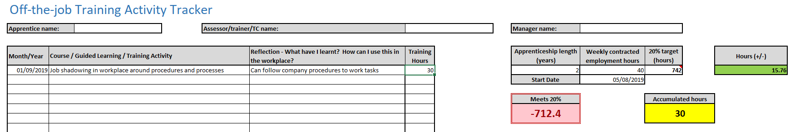

The overview hours you need to accumulate will remain red until you have met the total number of hours required for your apprenticeship. The yellow box will display your overall total.
You will be required to add the month and year for each entry. The activity entered will need to be clear and you will also need to reflect on what you have learnt during that activity.

Attaching 20% log to Ecordia

Log in to Ecordia and your ‘front page’ will be displayed.

Click on ‘contact log’ from the options
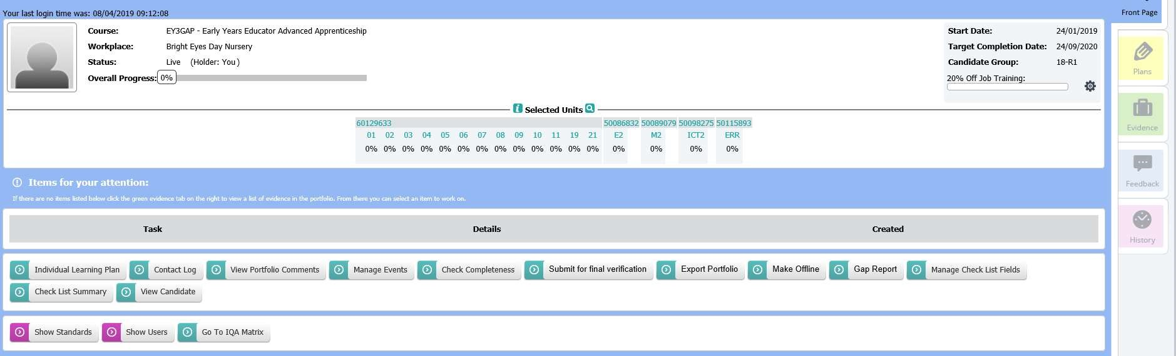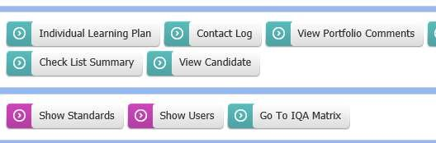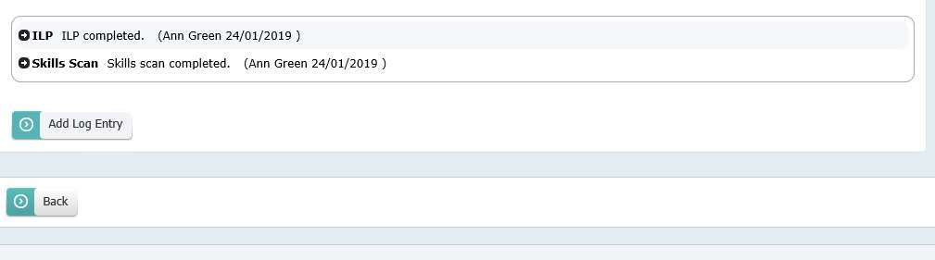

Click on ‘contact log’ from the options

Click on ‘add log entry’

Attaching 20% log to Ecordia

The following page will be displayed

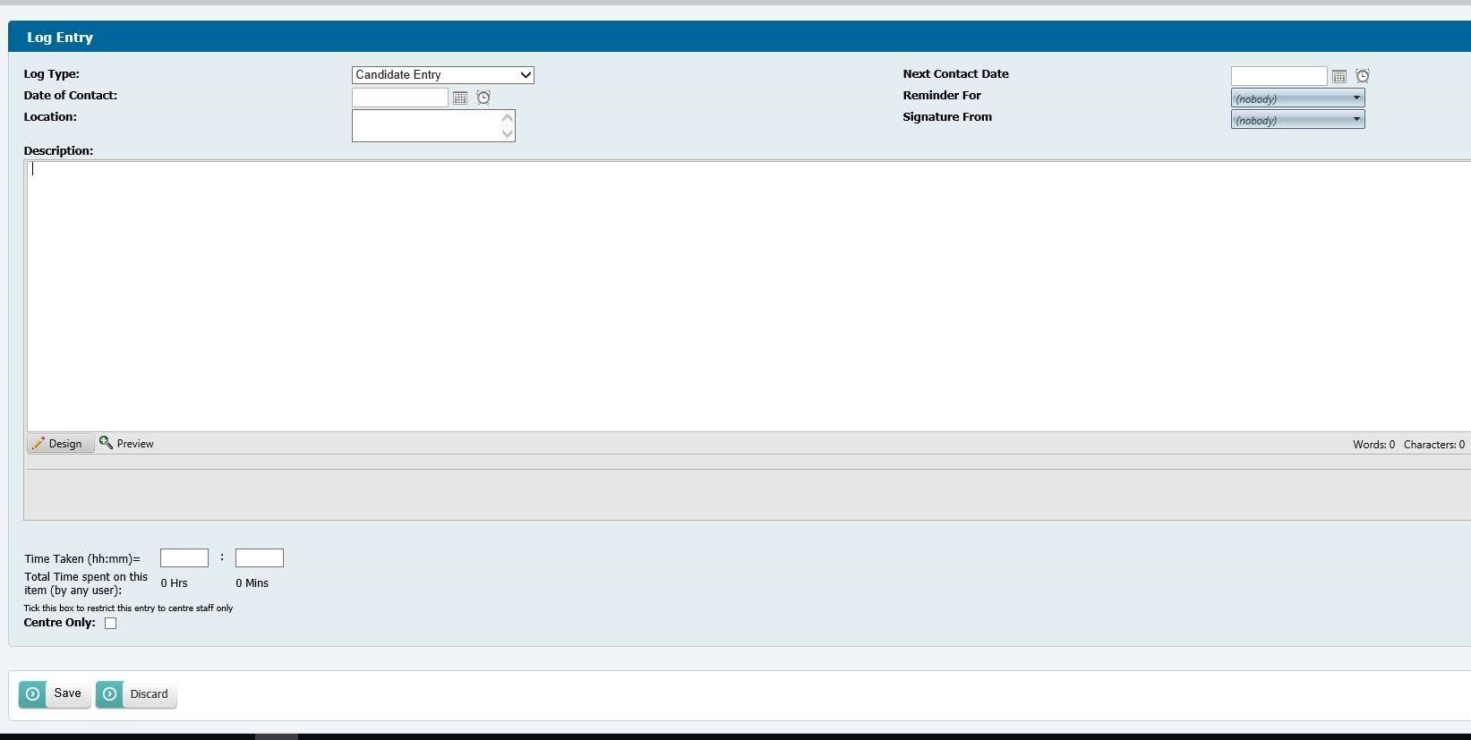
Choose “20% off the job training” from the log entry
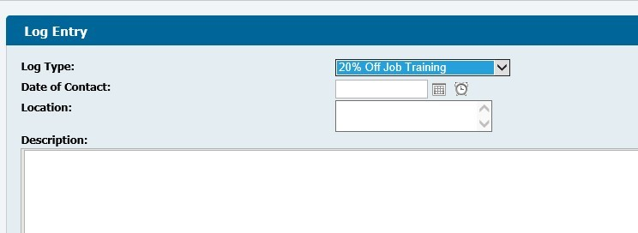
Enter the date that you are uploading your spreadsheet with the added 20% off the job
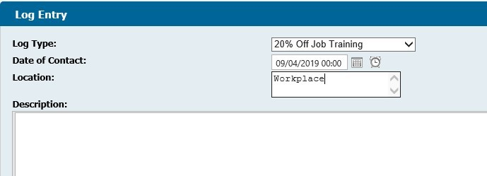
Attaching 20% off the job to Ecordia

Finally calculate the amount of time spent on 20% off the job since the last time you uploaded your spread-sheet and record the only these hours in the box at the end of the entry.

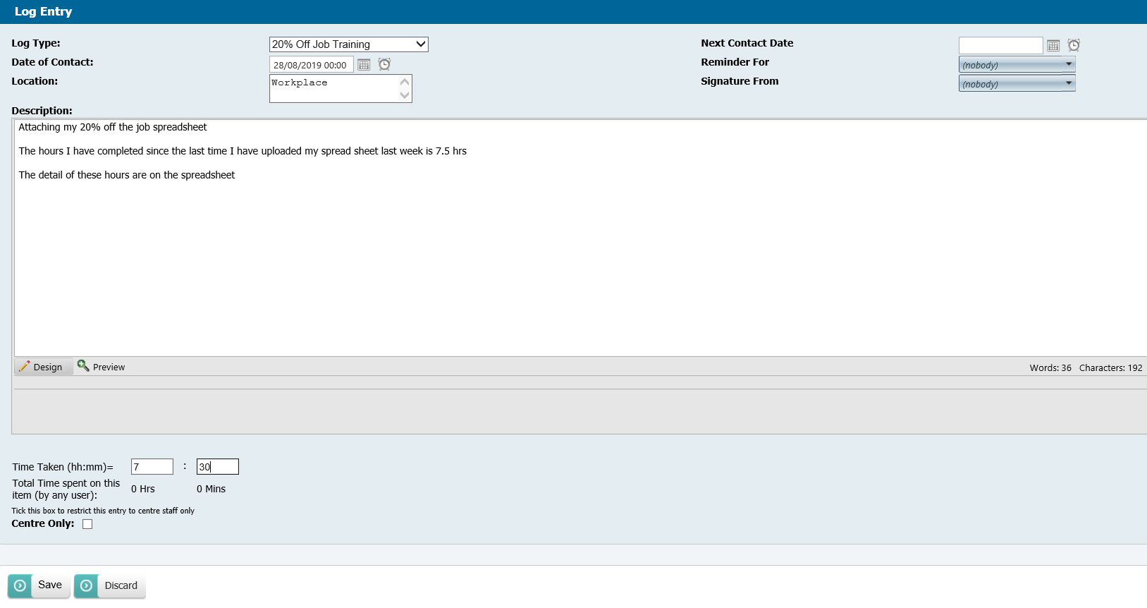
So every week when you are logging your 20% off the job training on Ecordia you will only be adding your current week’s hours, whilst your spread sheet will have the running total of all activities details since the start of your apprenticeship.



Functional Skills and using BKSB

BKSB
As part of your enrolment onto your apprenticeship programme you will have completed Initial Assessments and Diagnostic Assessments on BKSB.
These assessments help your trainers and assessors support you in developing your English and maths skills further even if you have concession for your English and maths.
The diagnostic tools clearly identify where you need to improve, them provide various activities to work through to enhance your abilities. If for any reason you have not completed your diagnostic assessments this needs to be done in the first couple of weeks at college. To log on to BKSB
Visit www.gloscol.ac.uk
Click ‘Log In’ just along from the college phone number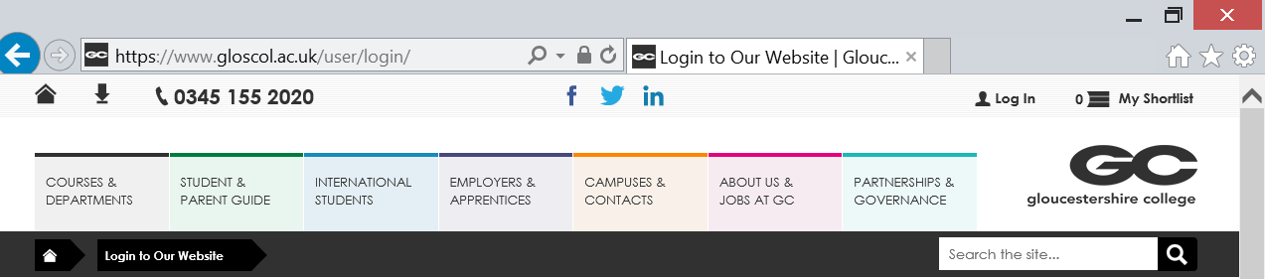
On the far right hand side where it says login to other college services pick BKSB Initial Assessment
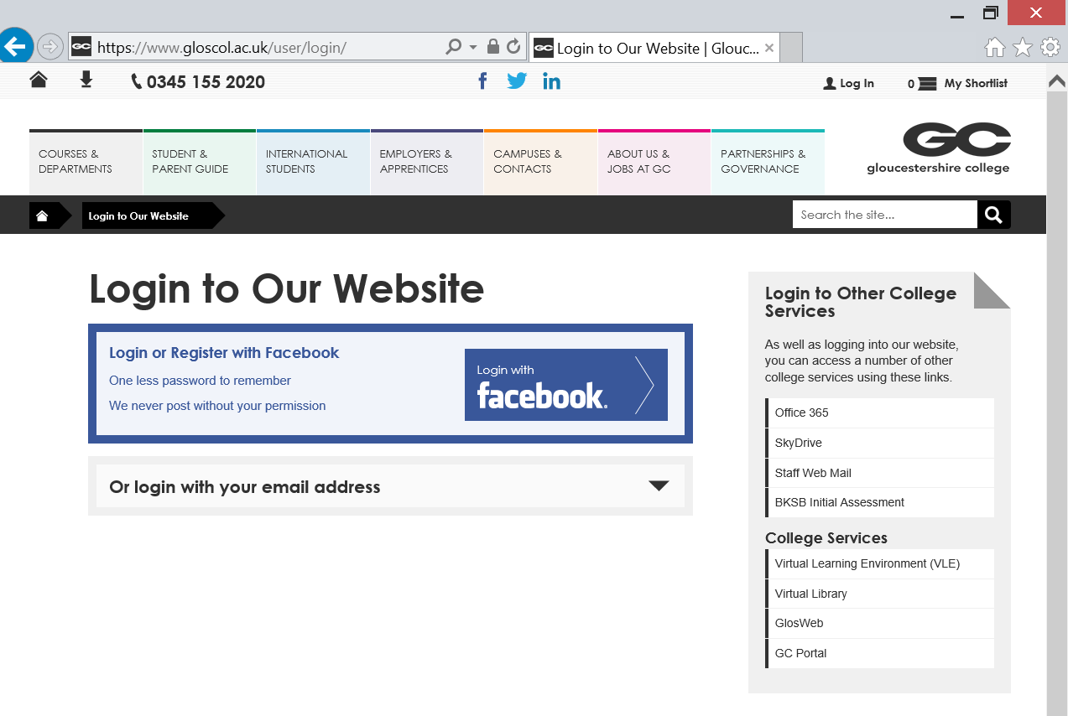

The BKSB assessment portal will load and you will be asked to log in.
  - Username: your Student ID No.
  - Password: password (all lowercase)
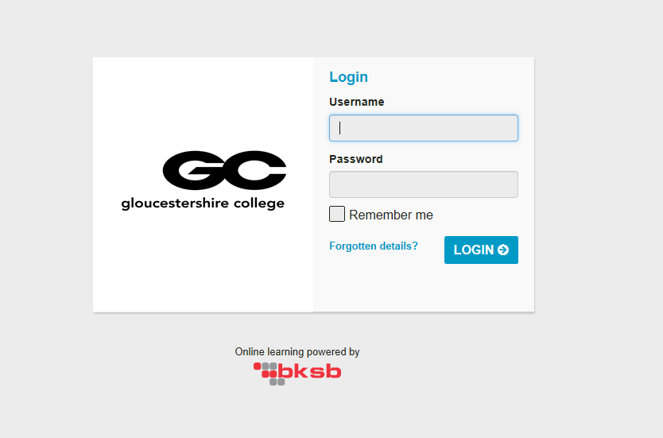

You will then be sent to your home page, please click on ‘Focus Functional Skills’
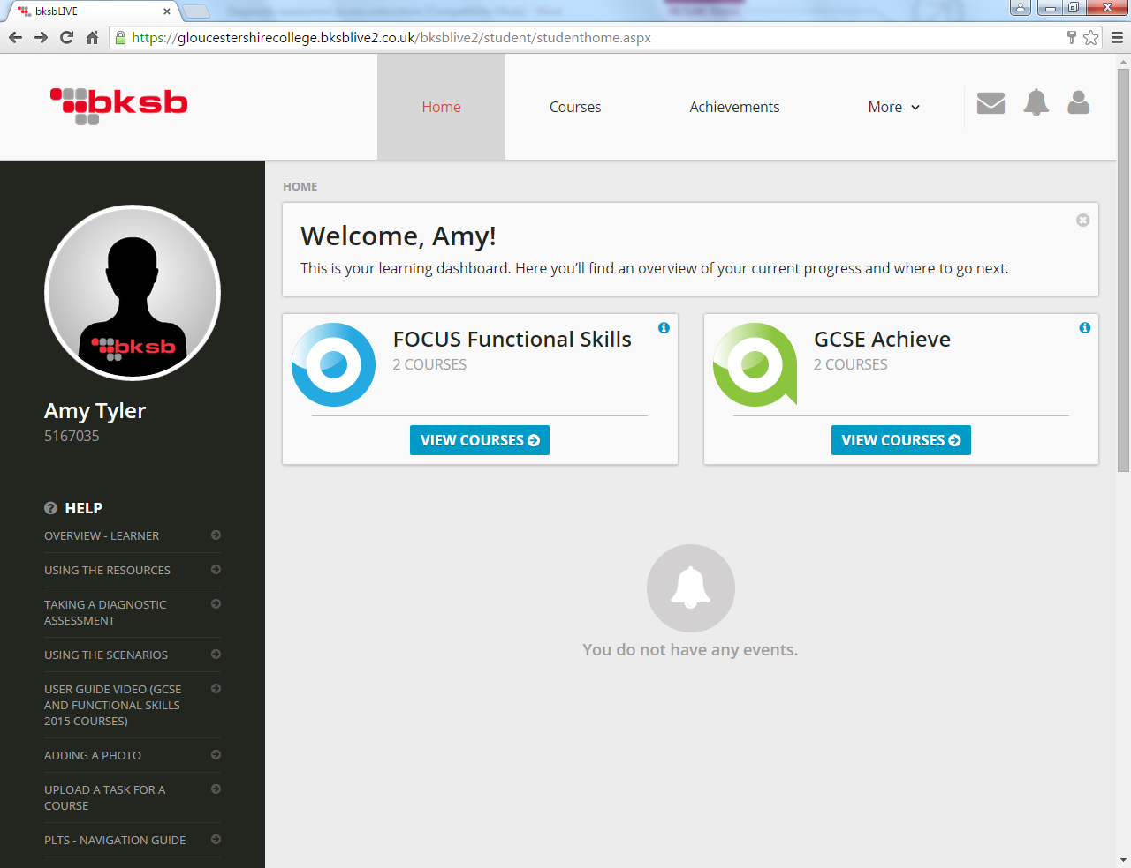

Please complete the following English and Maths Diagnostic test by clicking the ‘Continue’ button.
You will need to complete both the Maths and English initial assessment. They should take at least 15 minutes. It is important that you take your time and that your answers are your own.
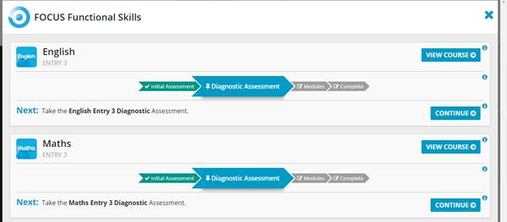
Your results will determine the support you receive and the level of work set for you.

Attending Functional Skills Classes

If you do not have your English and maths GCSE at grade 4 or above, you will be required to attend functional skills classes. These take place at Gloucester Campus in the Apprenticeship Hub and will be arranged between your Training Co-ordinator and your Employer.

Maths and English functional skills are delivered over a four-day workshop, attendance is 0900 – 1630 with the exam on the last day.

Some apprenticeship programmes also require ICT, if you do require this it will be delivered over a three-day workshop, attendance is 0900-1630, with the exam on the last day.

This is a fundamental part of your apprenticeship and failure to attend could lead to disciplinary procedures.

Gloucester


Gloucester Campus
Llanthony Road
Gloucester
GL2 5JQ

Tel: 01452 563400

Assessment and Verification

All Knowledge Skills and Behaviours are assessed holistically but may have a number of elements and use more than assessment methods.
You are required to complete a range of activities and produce a variety of written evidence which include:
- Written assignments – papers, reports, briefing
- Presentation slides
- Research/Literature reviews
- Self-Assessment
- Personal Development Plan
Assessment activities will be assessed by the trainer/assessor who delivered that unit/area of knowledge and will be graded as ‘Pass’ or ‘Refer’. If an assessment activity is referred, you will be given feedback to support you in reaching the necessary level of competence required to pass this element.
You will need to pass each element in order to pass the unit. You will need to successfully pass each unit in order to achieve the full qualification.
A proportion of your assignments will also sampled by an internal verifier. They check that the trainers’ assessments are appropriate, consistent and fair.

Appeals Procedure

Apprentices have the right to appeal against any assessment decision except where the awarding body does not permit this.

Stages of the appeal process

There are four stages to the appeals process. The flowchart can help provide guidance around these stages.
At stage 4 if you are unhappy with the decision made by the College Appeals Panel you have the right to escalate this to the Awarding Body for the qualification you are studying. For information concerning this process please refer to the Appeals Policy on the relevant Awarding Body Website.
The full assessment appeals procedure is on the General section of the VLE for this course.

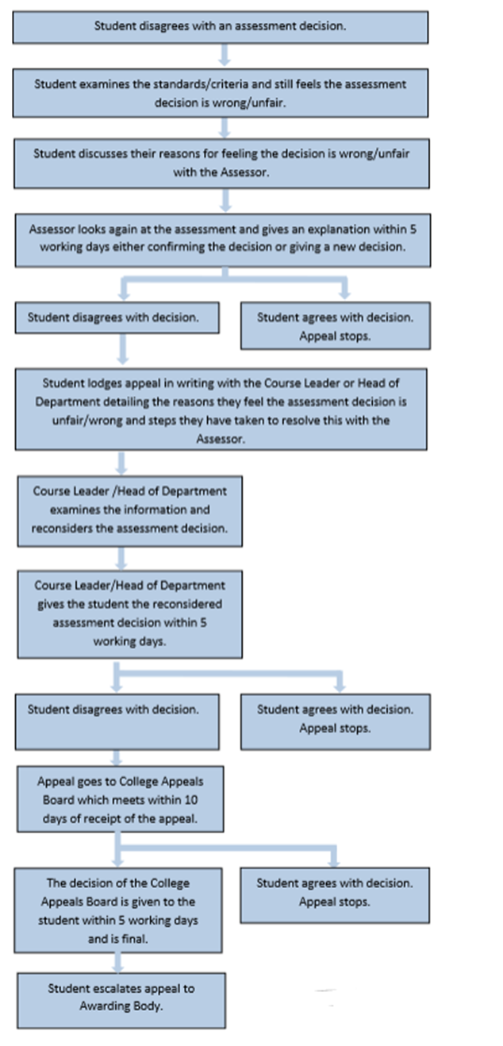
Appeals Procedure

Exams Regulations

If your course includes any exams, you need to be aware of the exam regulations which can be accessed on our website. The college is committed to protecting its integrity as an assessment and examination centre in line with awarding body regulations. At the same time the College is committed to providing learners with suitable conditions to enable fair, reliable, and valid assessment of learning.
During exam times you will not be allowed to bring any equipment into the room where you can access the internet, these include mobile phone, tablets and smart watches. Arrive in advance of the exam time and ensure that you leave your equipment with reception. A ticket will be provided to you so you can collect your equipment once the exam has finished. Ensure that you bring pens, pencils and equipment, such as calculators that you may need to complete your exam. Coats and bags will need to be left at the front of the room. You will receive exam information from your lecturer and further information before the exam commences.

Talkback procedure: complaints, compliments and feedback

Gloucestershire College values feedback from apprentices and employers to ensure we are continually improving our services and courses to meet the needs of individuals, employers and the local community.

The main way to provide the college with feedback, compliments and complaints, is through our Talkback system. Here are the various ways you can access Talkback:

- Talkback cards – these are available in public areas at various points throughout campuses, for example, at receptions, Student Services, dining areas, and in teaching rooms.
- Email - Talkback@gloscol.ac.uk
- Via the College website - www.gloscol.ac.uk or SharePoint.
- In writing - The Improvement Support Officer, Gloucestershire College, Llanthony Road, Gloucester, GL2 5RQ.

The full policy can be found here:
http://www.gloscol.ac.uk/media/995624/talkback-guidance-and-policy-pol-33-june-19-002.pdf

Additional Information
NUS Extra Apprentice Card

As a Gloucestershire College apprentice you are entitled to apply for a NUS Apprentice Card. In order to purchase your card, you will need to copy and paste the following link into your browser:
https://cards.nusextra.co.uk/
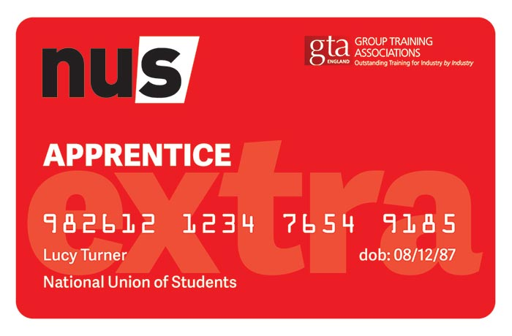

Travel Scheme

Gloucestershire has many buses and trains to help apprentices get to campus, and there are cheaper tickets available for learners aged 16-19. GC has teamed up with Stagecoach West and Michaels Travel to provide bus routes and discounted fares to our apprentices. Remember to show your student ID card to get a discounted fare from Stagecoach West. These discounts can be used for more than just College travel. You can get the cheap fares on weekends and other routes.
For more information about routes, travel costs and payment arrangements, visit
Https://www.gloucestershire.gov.uk/transport/thinksmart-apprentice-travel-scheme/

Apprentice Minimum Wage

For updates on the latest apprentice minimum wage please click on the government link below.
https://www.gov.uk/national-minimum-wage-rates


Litmos Hero’s
Litmos Hero’s is a bank of various short online courses in areas such as, Customer Service, Health and Safety, Management, etc. that you can access to build your skills and abilities in different areas click here to find out more:
https://gloucestershirecollege.litmos.com/account/login/?

Additional Information

College Counselling

There are many different situations and problems that happen in your life that can be difficult to deal with, especially when studying for your apprenticeship. Our counselling team can help you deal with many types of these problems, such as bullying, obsessive compulsive disorder (OCD), anxiety and depression, to name just a few. This support can be vital to help you cope and still achieve your apprenticeship.
The contact details of our Gloucestershire College Counselling Service (GCCS) are:

GCCS
Cheltenham College
Counselling for apprentice/students aged 18+
Email: counsellors@gloscol.ac.uk
Or call in to room F104 (Cheltenham Campus) for more information.
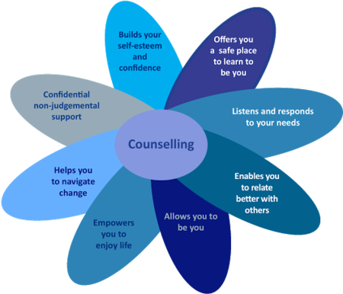

Parking Options for Apprentices

There is limited parking at the College. Apprentices can apply for a parking permit for Castle Meads carpark at Student Services. Its £3 per day, but on a first come, first serve basis.

