Windows Exam 70-698 Questions

Question 1
You have a computer named Computer1 that runs Windows 10.
File History is turned on.
The user of Computer1 reports that previous versions of D:\Folder\File1.doc are unavailable from the Previous Versions tab.
You need to ensure that the previous versions of the file are created.

Solution: Modify the Backup settings in the Settings app.

Does this meet the goal?

YES

Question 2
You have a computer named Computer1 that runs Windows 10.
File History is turned on.
The user of Computer1 reports that previous versions of D:\Folder\File1.doc are unavailable from the Previous Versions tab.
You need to ensure that the previous versions of the file are created.

Solution: Turn on System Protection for drive D.

Does this meet the goal?

NO

Question 3
You have a computer named Computer1 that runs Windows 10.
File History is turned on.
The user of Computer1 reports that previous versions of D:\Folder\File1.doc are unavailable from the Previous Versions tab.
You need to ensure that the previous versions of the file are created.

Solution: Create a backup of drive D by using Backup and Restore (Windows 7).
Does this meet the goal?
NO

Question 4
You have a computer named Computer1 that runs Windows 10.
File History is turned on.
The user of Computer1 reports that previous versions of D:\Folder\File1.doc are unavailable from the Previous Versions tab. You need to ensure that the previous versions of the file are created.

Solution: Add D:\Folder\to the Documents library.
Does this meet the goal?
YES

Question 5
Your network contains a single Active Directory domain named contoso.com. The domain contains two computers named Computer1 and Computer2.
A user named User1 is a member of the local Administrators group on Computer1 and Computer2.
User1 fails to access the Event Viewer logs on Computer2 from Computer1. User1 can connect to Computer2 remotely by using Computer Management.
You need to ensure that User1 can use Event Viewer on Computer1 to remotely view the Event Viewer logs on Computer2.

Solution: You start the Remote Registry services on Computer2.
Does this meet the goal?
NO

Question 6
A user has a computer that runs Windows 10.
The user reports that it takes a very long time to start the computer.
You need to identify which user applications cause the greatest delays when starting the computer.

Which tool should you use?
A. Performance Monitor
B. System Configuration
C. Resource Monitor
D. Task Manager

Question 7
You have a computer named Computer1 that has the following four hard disk drives installed:
Drive 1: A 500-GB OS volume
Drive 2: A 400-GB data volume
Drive3: A 400-GB empty volume
Drive 4: A 500-GB empty volume
You need to create a two-way mirror by using Storage Spaces. The solution must minimize data loss.

Which drives should you use?
A. Drive 1 and Drive 2
B. Drive 1 and Drive 4
C. Drive 2 and Drive 3
D. Drive 3 and Drive 4

Question 8
Your company is developing a Universal Windows Platform (UWP) app named App1. App1 is not published in the Windows Store.
You are provided with an AppX package for App1.
You need to install App1 locally.

What should you do first?
A. From a Group Policy object (GPO), add a software installation package.
B. From the Settings app, modify the For developers setting.
C. Set the AppX Deployment Service (AppXSVC) to Automatic and restart the computer.
D. Disable User Account Control (UAC).

Question 9
You purchase licenses for several apps from the Windows Store and you list the apps in your Windows Store for Business. You need to tell users how to install the apps.
What should you instruct the users to use?
A. the Windows Store app and a Microsoft account
B. a web browser and a Microsoft Azure Active Directory (Azure AD) account
C. the Windows Store app and a Microsoft Azure Active Directory (Azure AD) account
D. a web browser and a Microsoft account

Question 10
Your network contains a single Active Directory domain named adatum.com.
The network contains five servers configured as shown in the following table:

Server Name | Domain/workgroup | Role
DC1 | Adatum.com | Domain Controller
DC2 | Adatum.com | Domain Controller
Server1 | Adatum.com | Member Server
Server2 | Adatum.com | Member Server
Test_Server | Workgroup | File server

All of the servers run Windows Server 2012 R2.
Test_Server has a shared folder named ShareA. Only local users have permissions to ShareA. The network contains a mainframe computer that is administered by using the Telnet protocol. The domain contains four client computers configured as shown in the following table:

Computer Name | Primary User
Computer1 | User1
Computer2 | User2
Computer3 | User3
Computer4 | User4

All of the client computers run the 64-bit version of Windows 10. User3 frequently accesses ShareA. Remote Desktop is enabled on Computer4.
Your company identifies the following requirements:
- Ensure that you can test unsigned device drivers on Computer1.
- Enable Credential Guard on Computer2.
- Run commands and cmdlets remotely on Computer2.
- Configure User Account Control (UAC) on Computer3 to prompt administrators for credentials when elevated privileges are required.
- Ensure that User1 can view and interact with a desktop session of User3.
- Ensure that User2 can use Telnet to manage the mainframe.
- Ensure that User4 can use Remote Desktop to access Computer4 remotely.

You need to configure Computer3 to meet the UAC requirement. What should you use?

A. User Account Control Settings
B. Credential Manager
C. Security Options in the Computer Configuration of the Local Computer Policy.
D. Security Settings in the User Computer of the Local Computer Policy.

Question 11
Using the scenario in question 10
On Test_Server, you reset the password for User3.
You need to ensure that User3 can access ShareA.
Which tool should you instruct User3 to use on Computer3?
A. the Get-Credential cmdlet
B. Credential Manager
C. Authorization Manager
D. Active Directory Users and Computers

Question 12
Using the scenario in question 10
You need to meet the Credential Guard requirement of Computer2.
Which two Windows features should you install? Each correct answer presents part of the solution.

A. Windows Process Activation Service (WAS)
B. Embedded BootExperience
C. Isolated User Mode
D. Windows Identity Foundation 3.5
E. Hyper-V Hypervisor

Question 13
Using the scenario in question 10
You need to meet the requirement of User2. What should you do?
A. Run tlntadmn.exe
B. Install a Windows feature.
C. Modify the membership of the TelnetClients group.
D. Configure Windows Firewall.

Question 14
Note: This question is part of a series of questions that use the same set of answer choices. Each answer choice may be used once, more than once, or not at all.
Your network contains a single Active Directory domain. The domain contains a VPN server that supports all of the VPN protocols.
A user named User1 works from home and has a desktop computer that runs Windows 10 Pro. User1 has an application named App1 that requires access to a server on the corporate network. User1 creates a VPN connection on the computer.
You need to ensure that when User1 opens App1, App1 can access the required data.
What should you do?
A. Click Turn on password protected sharing.
B. Disable Network Discovery.
C. Modify the Profile settings of an incoming firewall rule.
D. Run the Add-VpnConnectionTriggerApplication cmdlet.
E. Run the New-NetFirewallRule cmdlet and specify the- Direction Outbound parameter.
F. Run the New-VpnConnection cmdlet.
G. Run the Set-NetConnectionProfile cmdlet.
H. Run the Set-VPNConnection cmdlet.

Question 15
Note: This question is part of a series of questions that use the same set of answer choices. Each answer choice may be used once, more than once, or not at all.
Your network contains a single Active Directory domain. The domain contains devices that run Windows 10 Enterprise.
You need to prevent computers from connecting to hosts on subnet 131.107.0.0/24.
What should you do?
A. Click Turn on password protected sharing.
B. Disable Network Discovery.
C. Modify the Profile settings of an incoming firewall rule.
D. Run the Add-VpnConnectionTriggerApplication cmdlet.
E. Run the New-NetFirewallRule cmdlet and specify the- Direction Outbound parameter.
F. Run the New-VpnConnection cmdlet.
G. Run the Set-NetConnectionProfile cmdlet.
H. Run the Set-VPNConnection cmdlet.

Question 16
Note: This question is part of a series of questions that use the same set of answer choices. Each answer choice may be used once, more than once, or not at all.
You have 10 computers that run Windows 10 Pro. The computers are in a workgroup.
A computer named PC_User1 has shared folder named Share1. Users are not prompted for credentials when they access Share1.
You modify the permissions on Share1 so that the share is shared only to a user named User1.
You need to ensure that when users from other computers in the workgroup access Share1, they must authenticate by using the credentials of User1.
What should you do?
A. Click Turn on password protected sharing.
B. Disable Network Discovery.
C. Modify the Profile settings of an incoming firewall rule.
D. Run the Add-VpnConnectionTriggerApplication cmdlet.
E. Run the New-NetFirewallRule cmdlet and specify the- Direction Outbound parameter.
F. Run the New-VpnConnection cmdlet.
G. Run the Set-NetConnectionProfile cmdlet.
H. Run the Set-VPNConnection cmdlet.

Question 17
Note: This question is part of a series of questions that use the same set of answer choices. Each answer choice may be used once, more than once, or not at all.
Your network contains a single Active Directory domain. The domain contains a VPN server that supports all of the VPN protocols.
From a computer that runs Windows 10 Pro, a user named User1 creates an SSTP VPN connection to a network named VPN1. User1 successfully connects to the VPN server. When User1 roams between different Wi-Fi access points, the user loses the connection to the corporate network and must manually re-establish the VPN connection.
You need to ensure that VPN1 automatically maintains the connection while the user roams between Wi-Fi access points.
What should you do?
A. Click Turn on password protected sharing.
B. Disable Network Discovery.
C. Modify the Profile settings of an incoming firewall rule.
D. Run the Add-VpnConnectionTriggerApplication cmdlet.
E. Run the New-NetFirewallRule cmdlet and specify the- Direction Outbound parameter.
F. Run the New-VpnConnection cmdlet.
G. Run the Set-NetConnectionProfile cmdlet.
H. Run the Set-VPNConnection cmdlet.

Question 18
Note: This question is part of a series of questions that use the same set of answer choices. Each answer choice may be used once, more than once, or not at all.
You have a computer named Computer1 that has storage configured as shown in the following table:
Disk name | Size | Storage Pool Name
Disk 1 | 200 GB | Pool1
Disk 2 | 100 GB | Pool1
Disk 3 | 500 GB | Pool1
Disk 4 | 500 GB | Pool2
Disk 5 | 500 GB | Pool2
Disk 6 | 800 GB | None
Disk 7 | 100 GB | Pool3
Disk 8 | 100 GB | Pool3
Pool1 contains a storage space named Space1 that is 300 GB. Pool3 contains a storage space named Space2 that is 100 GB. Pool2 is empty.
You need to add Disk6 to Pool1.
What should you use?
A. Add-PhysicalDisk
B. Diskpart
C. New-VirtualDisk
D. Remove-PhysicalDisk
E. Resize-VirtualDisk
F. Set-StoragePool
G. Subst
H. Update-Disk

Question 19
Using the scenario in question 18
Pool1 contains a storage space named Space1 that is 300 GB.
Pool3 contains a storage space named Space2 that is 100 GB.
Pool2 is empty.
Space1 contains 10 folders.

You need to access each folder as a separate drive from Windows Explorer. What should you use?
A. Add-PhysicalDisk
B. Diskpart
C. New-VirtualDisk
D. Remove-PhysicalDisk
E. Resize-VirtualDisk
F. Set-StoragePool
G. Subst
H. Update-Disk

Question 20
Using the scenario in question 18
Pool1 contains a storage space named Space1 that is 300 GB. Pool3 contains a storage space named Space2 that is 100 GB. Pool2 is empty.
You need to add a storage space to Pool2.
What should you use?
A. Add-PhysicalDisk
B. Diskpart
C. New-VirtualDisk
D. Remove-PhysicalDisk
E. Resize-VirtualDisk
F. Set-StoragePool
G. Subst
H. Update-Disk

Question 21
Using the scenario in question 18
Pool1 contains a storage space named Space1 that is 300 GB. Pool3 contains a storage space named Space2 that is 100 GB. Pool2 is empty.
You need to add Disk7 to Pool1.
What should you use first?
A. Add-PhysicalDisk
B. Diskpart
C. New-VirtualDisk
D. Remove-PhysicalDisk
E. Resize-VirtualDisk
F. Set-StoragePool
G. Subst
H. Update-DiskQuestion 22

Question 23
You have a computer that has a dual-boot configuration. Windows 10 Enterprise is installed on the local disk. Windows 10 Pro is installed in a VHDX file named Disk1.vhdx. Both of the installations are 64-bit versions.
You start the computer to Windows 10 Enterprise.
You need to ensure that you can install an unsigned driver to Windows 10 Pro when the computer starts in Windows 10 Pro.
What should you run?
A. Add-WindowsImage
B. bcdboot.exe
C. bcdedit.exe
D. bootcfg.exe
E. bootim.exe
F. bootsect.exe
G. diskpart.exe
H. Expand-WindowsImage

Question 24
You have a computer that has a dual-boot configuration. Windows 10 Pro is installed on the local disk. Windows 10 Enterprise is installed in a VHDX file named Disk1.vhdx.
You start the computer to Windows 10 Pro, and then you download a driver package.
You need to ensure that the next time the Windows 10 Enterprise installation starts, the driver is installed already. What should you run first?
A. Add-WindowsImage
B. bcdboot.exe
C. bcdedit.exe
D. bootcfg.exe
E. bootim.exe
F. bootsect.exe
G. diskpart.exe
H. Expand-WindowsImage

Question 25
You have a computer named Computer1 that has a dual-boot configuration. Computer1 has Windows 8.1 and Windows 10 installed.
You need to configure Computer1 to use only 4 GB of RAM when the computer starts in Windows 10.
What should you run?
A. Add-WindowsImage
B. bcdboot.exe
C. bcdedit.exe
D. bootcfg.exe
E. bootim.exe
F. bootsect.exe
G. diskpart.exe
H. Expand-WindowsImage

Question 26
Your network contains a single Active Directory domain named contoso.com. All computers are members of the domain and run the 64-bit version of Windows 10 Enterprise.
On a test computer named Computer_Test1, you pin several company-specific applications in a group named Contoso Apps, and then you export the Start menu layout to a file named Contoso.xml.
You install Client Hyper-V on a computer named Computer6.

- You identify the following requirements:
- Install the Hyper-V feature on a computer named Computer1.
- Use virtual smart card authentication on a computer named Computer2.
- Enable Secure Boot on a computer named Computer3.
- Connect a computer named Computer4 to a projector by using Miracast.
- Ensure that a user named User1 can use keyboard shortcuts by pressing one key at a time.
- Ensure that you can share the clipboard between Computer6 and the virtual machines running on Computer6.
- Add the Contoso Apps group to the Start menu of a computer named Computer7.

You install all of the Contoso apps on Computer7.
You need to meet the requirements of Computer7. What should you do?
A. Run the Import-StartLayout cmdlet.
B. Copy Contoso.xml to the C:\Users\Default\Start menu folder.
C. Configure the Start Menu and Taskbar settings in a Group Policy.
D. Copy Contoso.xml to the C:\ProgramData\Microsoft\Windows\Start Menu folder.

Question 27
Your network contains a single Active Directory domain named contoso.com. All computers are members of the domain and run the 64-bit version of Windows 10 Enterprise.
On a test computer named Computer_Test1, you pin several company-specific applications in a group named Contoso Apps, and then you export the Start menu layout to a file named Contoso.xml.
You install Client Hyper-V on a computer named Computer6.

- You identify the following requirements:
- Install the Hyper-V feature on a computer named Computer1.
- Use virtual smart card authentication on a computer named Computer2.
- Enable Secure Boot on a computer named Computer3.
- Connect a computer named Computer4 to a projector by using Miracast.
- Ensure that a user named User1 can use keyboard shortcuts by pressing one key at a time.
- Ensure that you can share the clipboard between Computer6 and the virtual machines running on Computer6.
- Add the Contoso Apps group to the Start menu of a computer named Computer7.

Which hardware feature must Computer4 must support?

A. a Wi-Fi adapter
B. a Bluetooth adapter
C. an HDMI port
D. a MiniDisplayPort connector

Question 28
Your network contains a single Active Directory domain named contoso.com. All computers are members of the domain and run the 64-bit version of Windows 10 Enterprise.
On a test computer named Computer_Test1, you pin several company-specific applications in a group named Contoso Apps, and then you export the Start menu layout to a file named Contoso.xml.
You install Client Hyper-V on a computer named Computer6.

- You identify the following requirements:
- Install the Hyper-V feature on a computer named Computer1.
- Use virtual smart card authentication on a computer named Computer2.
- Enable Secure Boot on a computer named Computer3.
- Connect a computer named Computer4 to a projector by using Miracast.
- Ensure that a user named User1 can use keyboard shortcuts by pressing one key at a time.
- Ensure that you can share the clipboard between Computer6 and the virtual machines running on Computer6.
- Add the Contoso Apps group to the Start menu of a computer named Computer7.

You install all of the Contoso apps on Computer7.
You need to meet the requirement of Computer6. What should you configure?
A. NUMA spanning
B. enhanced session mode
C. Hyper-V Guest Service Interface
D. RemoteFX

Question 29
Your network contains a single Active Directory domain named contoso.com. All computers are members of the domain and run the 64-bit version of Windows 10 Enterprise.
On a test computer named Computer_Test1, you pin several company-specific applications in a group named Contoso Apps, and then you export the Start menu layout to a file named Contoso.xml.
You install Client Hyper-V on a computer named Computer6.

- You identify the following requirements:
- Install the Hyper-V feature on a computer named Computer1.
- Use virtual smart card authentication on a computer named Computer2.
- Enable Secure Boot on a computer named Computer3.
- Connect a computer named Computer4 to a projector by using Miracast.
- Ensure that a user named User1 can use keyboard shortcuts by pressing one key at a time.
- Ensure that you can share the clipboard between Computer6 and the virtual machines running on Computer6.
- Add the Contoso Apps group to the Start menu of a computer named Computer7.

You need to meet the requirement of User1.
Which Ease of Access setting should you configure?
A. Toggle Keys
B. Sticky Keys
C. Filter Keys
D. Mouse Keys

Question 30

You have a computer named Computer1 that runs Windows 10.
You run the Get-VMHost | fl* cmdlet on Computer1, and you receive the following output:
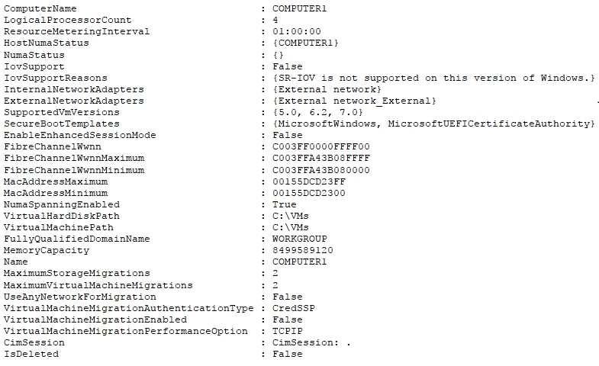
Which of the following are valid? (Choose 2)
You cannot perform storage migrations on Computer1
You can perform a maximum of two storage migrations on Computer1
You can perform a maximum of four storage migrations on Computer1
You can perform a maximum of eight storage migrations on Computer1
You cannot perform virtual machine migrations from Computer1 to another Hyper-V host
You can perform a maximum of two concurrent virtual machine migrations from Computer1 to another Hyper-V host
You can perform a maximum of four concurrent virtual machine migrations from Computer1 to another Hyper-V host
You can perform a maximum of eight concurrent virtual machine migrations from Computer1 to another Hyper-V host

Question 31
Your network contains a single Active Directory domain named contoso.com.
In contoso.com, you create an organizational unit (OU) named OU1.
You need to use a provisioning package to perform the following:
Configure the computer names as “Station”, followed by a random three-digit number.
Join the computers to contoso.com, and then create an account for the computers in OU1
What is the value of the AccountOU property?
Contoso.com/OU1
Ldap://contoso.com/OU1
OU=OU1, AD=contoso.com
OU=OU1, DC=contoso, DC=com
What is the value of the ComputerName property?

Station#Num 3
Station$NNN$
Station%RAND:3%
Station [\D:3]

Question 32
You have a computer named Computer1.
You obtain a new driver for a device installed on Computer1. The driver package is stored in C:\Drivers and includes the following files:
Driver.inf
Driver.dll
Driver.sys
Driver.cat

You need to install the driver on Computer1 by using File Explorer. Which file should you use to initiate the installation?

Question 33
You have four computers configured as shown in the following table:
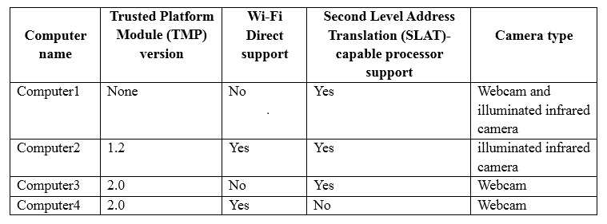
You need to deploy Windows 10 Enterprise. The deployment must support Miracast, BitLocker Drive Encryption (BitLocker), and Windows Hello with facial recognition.
On which computer should you install Windows 10?
A. Computer1
B. Computer2
C. Computer3
D. Computer4

Question 34
You configure a Group Policy on a computer that runs Windows 10 Enterprise as shown in the following graphic:
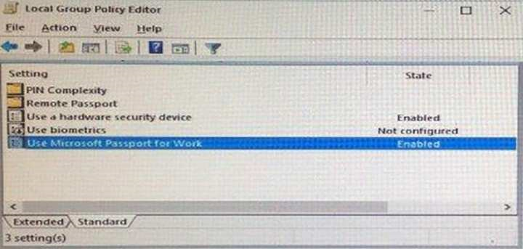
Which of the following are valid (choose two)?
To sign in to the computer the user must always enter a PIN
To sign in to the computer the user can use a PIN or a hardware security device
To sign in to the computer the user must always use a hardware security device
For this configuration a USB key protector is required
For this configuration a Trusted Platform Module (TPM) chip is required
For this configuration a second level address translation (SLAT) capable processor is required

Question 35
You have a computer that runs the 32-bit version of Windows 7 Professional.
You need to perform an in-place upgrade to Windows 10.
Which two editions of Windows 10 can you upgrade the computer to? Each correct answer presents a complete solution.
A. the 32-bit version of Windows 10 Pro
B. the 64-bit version of Windows 10 Pro
C. the 32-bit version of Windows 10 Enterprise
D. the 64-bit version of Windows 10 Enterprise
E. the 32-bit version of Windows 10 Home

Question 36
You have five computers that run Windows 8.1 Pro.
You need to perform an upgrade installation of Windows 10 on the computers.
What are two possible ways to achieve the goal? Each correct answer presents a complete solution.

A. Apply an image of Windows 10 by running imagex.exe.
B. Start the computers from Windows PE, and then run setup.exe from a network share that contains the Windows 10 installation source files.
C. While signed in to Windows 8.1 Pro, run setup.exe from a network share that contains the Windows 10 installation source files.
D. Start the computers from a bootable USB drive that contains the Windows 10 source files.
E. Apply updates by using Windows Update.

Question 37
You have a computer named Computer1 that runs the 64-bit version of Windows 10 Pro.
You obtain a new driver for a device installed on Computer1. The driver is not digitally signed.
You need to test the installation of the driver on Computer1.
What should you do first?
A. Run dism.exe and specify the /Add-Driver and /Force-Unsigned parameters.
B. From User Configuration in Group Policy, configure the Driver Installation settings.
C. Restart Computer1 by using the advanced startup options.
D. From Computer Configuration in Group Policy, configure the Driver Installation settings.

Question 38
You have 10 computers that run Windows 10 Pro.
The computers currently receive updates as part of the Current Branch.
You need to configure the computers to receive updates as part of Current Branch for Business.
What should you do?

A. Select the Defer upgrades check box.
B. Upgrade to Windows 10 Enterprise.
C. Change the product key.
D. Clear the Give me updates for other Microsoft products when I update check box

Question 39
You have the following output from Windows PowerShell:
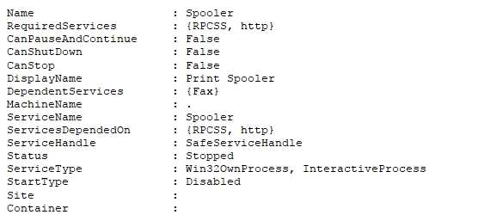
You need to start the service.

What command should you run first?
Restart-Service - Spooler
Resume-Service - Spooler
Set-Service -Spooler
Start-Service –Spooler

With which option?
-$True
-CanShutdown $False
-Force
-StartupType Automatic
-Status Start

Question 40

You have computers that run Windows 10.
You need to identify both active malware instances and past malware instances from the last three months.
Which command should you run?

A. Get-EventSubscriber
B. Get-MpThreatCatalog
C. Get-WindowsErrorReporting
D. Get-MpThreatDetection

Question 41
Your networks contain a single Active Directory domain.
On a domain controller, an administrator creates a custom Microsoft Management Console (MMC) that uses the Active Directory Users and Computer snap-in. The domain contains a computer named Computer1 that runs Windows 10. You use the computer to perform management tasks. You copy the custom MMC to the computer.
You need to ensure that you can use MMC and all of the features of the MMC.
What should you do on Computer1?

A. Enable the Sideload apps developer feature.
B. Install the Remote Server Administration Tools (RSAT).
C. Install the Microsoft Application Compatibility Toolkit (ACT).
D. Disable User Account Control (UAC).

Question 42
You have a computer named Computer1 that runs Windows 10.
Computer1 has two volumes named C and D. Volume C is formatted NTFS and volume D is formatted exFAT. You need to ensure that you can recover files stored in D:\Data.
What should you use?

A. System Restore points
B. File History
C. wbadmin.exe
D. Backup and Restore (Windows 7)

Question 43
You have a computer named Computer1 that has a 1-TB volume named E.
You need to receive a notification when volume E has less than 100 GB of free space.
Which tool should you use?

A. Event Viewer
B. Disk Cleanup
C. Performance Monitor
D. System Configuration
E. Resource Monitor

Question 44
You have a Windows Server Update Services (WSUS) server.
You need to configure a computer to receive updates from WSUS. The solution must ensure that the updates are installed only on Sunday at 20:00.
Which two settings should you configure?

Question 45
You deploy a new computer named Computer1.
You have a file named Data.docx that is stored in Microsoft OneDrive.
From File Explorer, you attempt to open Data.docx, but you discover that the file is corrupt.
You need to access a previous version of Data.docx.

What should you use?

A. File History
B. the Recycle Bin
C. One Drive online
D. Backup and Restore (Windows 7)

Question 46
You have a computer named Computer1 that runs Windows 10.
File History is turned on.
You have files located in D:\Photos.
You need to ensure that you can recover previous versions of the files in D:\Photos.
What should you do?
A. Add D:\Photos to the Pictures library.
B. Turn on System Protection for drive D.
C. Enable sharing for D:\Photos.
D. Modify the Recovery settings in the Settings app.

Question 47
You have a computer that runs Windows 10 Pro.
You receive a SMART alert that the hard disk drive will fail soon.
You connect a second external hard disk drive to the computer.
You need to create a backup that you can use to restore the operating system and the user documents to a replacement drive.

What should you use?

A. vssadmin.exe
B. wbadmin.exe
C. Start-WBBackup
D. Start-OBBackup

Question 48
A user reports that a computer was slower than expect during the last week. You need to identify any application failures that occurred during the last week.

Which tool should you use?

A. Performance Monitor
B. Task Manager
C. Resource Monitor
D. Reliability Monitor

Question 49
You have a computer named Computer1 that runs Windows 10. Computer1 has a printer named Printer1 installed.
You need to configure the settings of Printer1 remotely from another computer.

Which tool should you use on the remote computer?

A. Device Manager from Control Panel
B. Print Management from Administrative Tools
C. Printers & scanners from the Setting app
D. Devices and Printers from Control Panel

Question 50
You run the Get-Service cmdlet and you receive the following output:
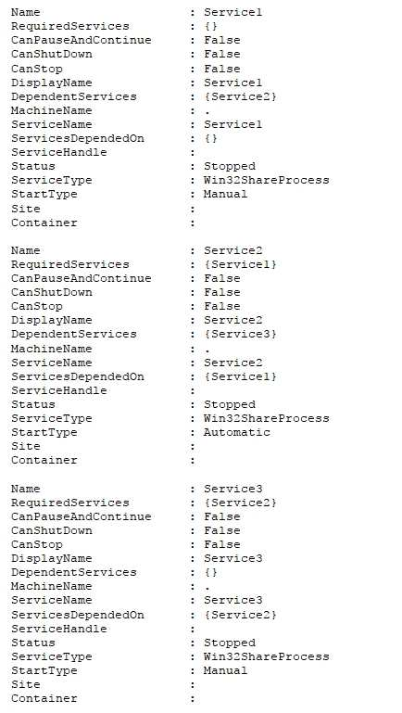

You need to identify what occurs when the status of the services changes.
What should you identify? (Choose 3)
If Service3 starts, the Service1 service remains stopped
If Service3 starts, the Service1 service starts

If Service1 starts, the Service3 service remains stopped
If Service1 starts, the Service3 service starts

If Service2 starts, the Service3 service remains stopped
If Service2 starts, the Service3 service starts

Question 51
You configure the Group Policy settings on a computer that runs Windows 10 as shown in the following graphic:

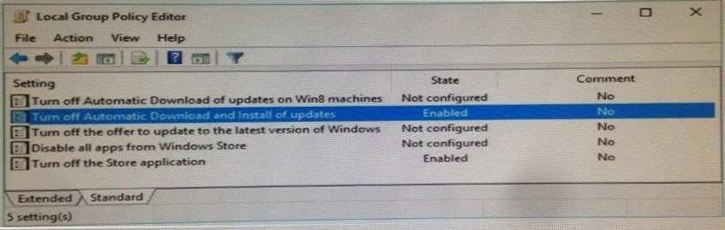

Select the correct two answer choices
On the computer the Windows store app will be unavailable
On the computer the Windows store app will have updates installed
On the computer the Windows store app will be available to administrators only
All pre-installed applications will be updated
All pre-installed applications cannot be launched
All pre-installed applications will never receive updates

Question 52
Your network contains a single Active Directory domain. The domain contains a computer that runs Windows 10.
You plan to use the computer to test applications.
You need to install Windows Insider Preview builds on the computer.
What should you do?
A. From Group Policy, configure the Add features to Windows 10 settings.
B. From the Settings app, configure the Advanced options for Windows Update.
C. From Group Policy, configure the Windows Update settings.
D. From the Settings app, select Developer mode.

Question 53
You have a computer named Computer1 that has the following stored credentials:
A Windows credential for accessing a shared folder on a workgroup computer
A Windows credential for accessing Remote Desktop
A Windows credential for accessing an HTTP URL
A web credential for accessing an HTTPS URL
A web credential for accessing an HTTP URL

Which two passwords can be viewed in clear text from Credential Manager on Computer1?

A. the web credential for accessing the HTTPS URL
B. the Windows credential for accessing the shared folder
C. the Windows credential for accessing the HTTP URL
D. the Windows credential for accessing Remote Desktop
E. the web credential for accessing the HTTP URL

Question 54
You have a computer named Computer1 that is configured to install updates from Windows Server Update Services (WSUS).
Microsoft releases a new Windows update that is not approved in WSUS.
You need to install the update on Computer1.
What should you do?
A. From a command prompt, run gpupdate /force /sync.
B. Click Check online for updates from Microsoft Updates, and then check for updates.
C. Clear the defer upgrades check box, and then check for updates.
D. From Windows PowerShell, run the Get-WindowsUpdateLog cmdlet, and then run the Update- Module cmdlet.

Question 55
You have a computer named Computer1.
A user named User1 is a member of two groups named Group1 and Group2.
You have a file named Doc1.docx that is located in E:\Data.
The file permissions for E:\Data\Doc1.docx are configured as shown
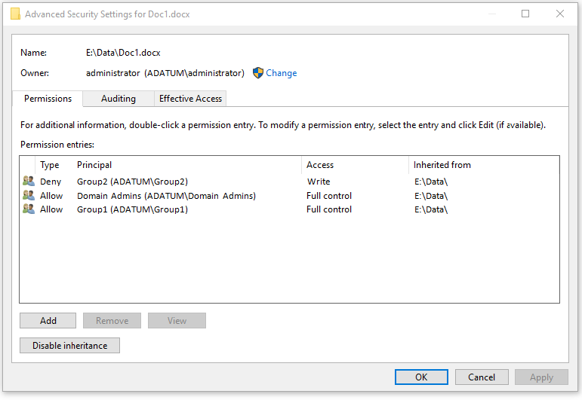
You need to provide User1 with Write access to Doc1.docx. What should you do?
A. Grant User1 Full control access to folder E:\Data.
B. Remove User1 from Group2 and instruct the user to sign out, and then sign back in.
C. Grant User1 Full control access to the E:\Data\Doc1.docx file, disable inheritance for the file, and then convert the inherited permissions to explicit permissions for the file.
D. Grant User1 Write access to folder E.

Question 56
You have a laptop named Computer1 that runs Windows 10.
Computer1 connects to a wireless network named WiFi1 and a wireless network named WiFi2. WiFi1 has poor signal and the connection drops frequently. WiFi2 is available only during certain times of the day. WiFi2 has a stronger signal that is more reliable than WiFi1.
You need to configure Computer1 to use WiFi2 whenever possible. WiFi1should be used when WiFi2 is unavailable.
Which three settings should you configure? Each correct answer presents part of the solution.
A. From the properties of WiFi2, select Connect even if the network is not broadcasting its name (SSID)
B. From the properties of WiFi1, select Connect automatically when this network is in range.
C. From the properties of WiFi1, select Enable WLAN connection settings.
D. From the properties of WiFi2, select Connect automatically when this network is in range.
E. From the properties of WiFi1, select Look for other wireless networks while connected to this network.
F. From the properties of WiFi2, select Look for other wireless networks while connected to this network.

Question 57
You have a computer named Computer1 that runs Windows 10.
On Computer1, C:\Folder1 has the permissions configured as shown in the following table.
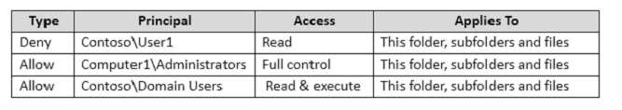
You share C:\Folder1 as Folder1 and you grant access to the Everyone group. Folder1 has the following share settings:
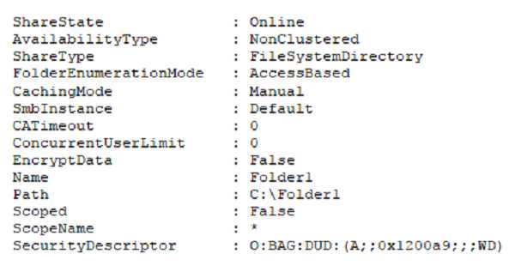
What level of access does User1 have to Folder1?
A. User1 cannot see the Folder1 share on the network and cannot connect to Folder1.
B. User1 can see the Folder1 share on the network and can connect to Folder1.
C. User1 cannot see the Folder1 share on the network but can connect to Folder1.
D. User1 can see the Folder1 share on the network but cannot connect to Folder1.

Question 58
Your company uses a Window Store for Business that contains an app named App1.
You have three computers that are prevented from accessing the Internet.
You need to distribute App1 to the three computers.
What are two possible ways to achieve the goal? Each correct answer presents a complete solution.
A. a provisioning package created by using Windows Imaging and Configuration Designer
B. A deployment from Microsoft Intune.
C. A deployment from Windows Deployment Services (WDS)
D. an AppX package deployed by using Deployment Imaging Servicing and Management (DISM)
E. an answer file created by using Windows System Image Manager (Windows SIM)

Question 59
Your network contains a single Active Directory domain named contoso.com.
The domain contains two computers named Computer1 and Computer2 and a domain controller named DC1.
On Computer1, you run the net user User1 command and you receive the following output:
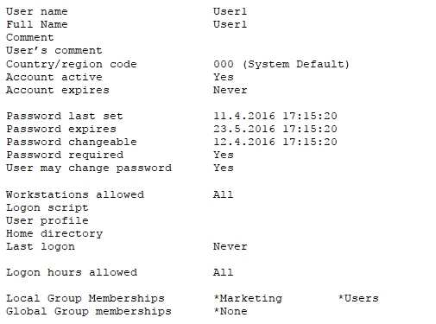
Select two correct answers
You can configure Logon hours for User1 by using the Local Users and Groups console
You can configure Logon hours for User1 by using the Net Accounts command
You can configure Logon hours for User1 by using the Net user command
You can configure Logon hours for User1 by using the Set-ADObject cmdlet
You can configure Logon hours for User1 by using the Set-ADUser cmdlet
User1 can sign in to Computer1 only
User1 can sign in to Computer1 and Computer2 only
User1 can sign in to Computer1, Computer2 and DC1

Question 60
Your network contains a single Active Directory domain named contoso.com.
The domain contains two computers named Computer1 and Computer2.
A user named User1 is a member of the local Administrators group on Computer1 and Computer2. User1 fails to remotely manage the devices on Computer2 by using Device Manager on Computer1. User1 can connect to Computer2 remotely by using Computer Management.
You need to ensure that User1 can disable a device on Computer2 remotely.
Solution: You enable Remote Desktop on Computer2, and you instruct User1 to use Remote Desktop. Does this meet the goal? YES

Question 61
Your network contains a single Active Directory domain named contoso.com.
The domain contains two computers named Computer1 and Computer2.

A user named User1 is a member of the local Administrators group on Computer1 and Computer2.
User1 fails to remotely manage the devices on Computer2 by using Device Manager on Computer1.
User1 can connect to Computer2 remotely by using Computer Management.

You need to ensure that User1 can disable a device on Computer2 remotely.
Solution: You start the Plug and play and Remote Registry services on Computer2.
Does this meet the goal? NO

Question 62
Your network contains a single Active Directory domain named contoso.com. The domain contains two computers named Computer1 and Computer2.
A user named User1 is a member of the local Administrators group on Computer1 and Computer2.
User1 fails to remotely manage the devices on Computer2 by using Device Manager on Computer1.
User1 can connect to Computer2 remotely by using Computer Management.

You need to ensure that User1 can disable a device on Computer2 remotely.
Solution: You enable the Allow remote access to the Plug and Play interface Group Policy setting on Computer2.
Does this meet the goal? NO

Question 63
While performing maintenance on a computer, you open Indexing Options, and then you click Pause. You complete the computer maintenance.
You need to resume indexing.
Solution: From the Start menu, you click Power and then you click Restart.
Does this meet the goal? YES

Question 64
While performing maintenance on a computer, you open Indexing Options, and then you click Pause.
You complete the computer maintenance.
You need to resume indexing.
Solution: From the Services console, you restart the Storage Service service.
Does this meet the goal? NO

Question 65
While performing maintenance on a computer, you open Indexing Options, and then you click Pause.
You complete the computer maintenance.
You need to resume indexing.
Solution: From the Services console, you restart the Windows Search service.
Does this meet the goal? YES

Question 66
While performing maintenance on a computer, you open Indexing Options, and then you click Pause.
You complete the computer maintenance.
You need to resume indexing.
Solution: You sign out of Windows, and then you sign back in. Does this meet the goal? NO

Question 67
You have a computer named Computer1 that has storage configured as shown in the following table.
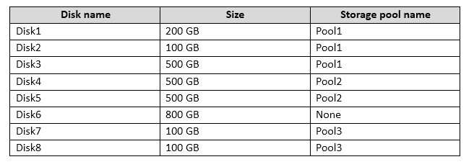
Pool1 contains a storage space named Space1 that is 300 GB. Pool3 contains a storage space named Space2 that is 100 GB. Pool2 is empty.
You need to configure Space2 to be 200 GB.
What should you use?
A. Add-PhysicalDisk
B. Diskpart
C. New-VirtualDisk
D. Remove-PhysicalDisk
E. Resize-VirtualDisk
F. Set-StoragePool
G. Subst
H. Update-Disk

Question 68
You have a computer named Computer1 that has storage configured as shown in the following table.
Pool1 contains a storage space named Space1 that is 300 GB. You discover that Disk2 experiences physical errors.
You need to ensure that all of the data in Space1 is stored on other disks in the storage pool only.
What should you use?
A. Add-PhysicalDisk
B. Diskpart
C. New-VirtualDisk
D. Remove-PhysicalDisk
E. Resize-VirtualDisk
F. Set-StoragePool
G. Subst
H. Update-Disk

Question 69
You have a computer named Computer1 that has storage configured as shown in the following table.
Pool1 contains a storage space named Space1 that is 300 GB. Pool3 contains a storage space named Space2 that is 100 GB. Pool2 is empty. Disk8 fails.
You add a new disk named Disk9 to Pool3. You need to remove Disk8 from Pool3.
What should you use?
A. Add-PhysicalDisk
B. Diskpart
C. New-VirtualDisk
D. Remove-PhysicalDisk
E. Resize-VirtualDisk
F. Set-StoragePool
G. Subst
H. Update-Disk

Question 70
You have a computer named Computer1.
Computer1 has a virtual hard disk (VHD) named Disk1.vhdx. Disk1.vhdx has an NTFS partition, which is visible in File Explorer as drive E.
You need to apply a Windows 10 image to drive E.
What should you run?
A. Add-WindowsImage
B. bcdboot.exe
C. bcdedit.exe
D. bootcfg.exe
E. bootim.exe
F. bootsect.exe
G. diskpart.exe
H. Expand-WindowsImage

Question 71
Your network contains a single Active Directory domain. The domain contains a VPN server that supports all of the VPN protocols.
You have mobile devices that run Windows 10 and have VPN connections to the VPN server.
You need to ensure that when users work remotely and connect to the VPN, only traffic for the corporate network is sent through the VPN server. What should you do?
A. Click Turn on password protected sharing.
B. Disable Network Discovery.
C. Modify the Profile settings of an incoming firewall rule.
D. Run the Add-VpnConnectionTriggerApplication cmdlet.
E. Run the New-NetFirewallRule cmdlet and specify the-Direction Outbound parameter.
F. Run the New-VpnConnection cmdlet.
G. Run the Set-NetConnectionProfile cmdlet.
H. Run the Set-VPNConnection cmdlet.

Question 72
A user connects to a wireless network and receives the following message:
"Do you want to allow your PC to be discoverable by other PCs and devices on this network?"
The user clicks No. The user is unable to browse to the shared folders of other computers on the network by using File Explorer.
You need to ensure that the user can browse to the other computers.
What should you do?
A. Click Turn on password protected sharing.
B. Disable Network Discovery.
C. Modify the Profile settings of an incoming firewall rule.
D. Run the Add-VpnConnectionTriggerApplication cmdlet.
E. Run the New-NetFirewallRule cmdlet and specify the -Direction Outbound parameter.
F. Run the New-VpnConnection cmdlet.
G. Run the Set-NetConnectionProfile cmdlet.
H. Run the Set-VPNConnection cmdlet.

Question 73
Your network contains a single Active Directory domain. The domain contains computers that run Windows 10 Enterprise.
The computers are configured as shown in the following table:
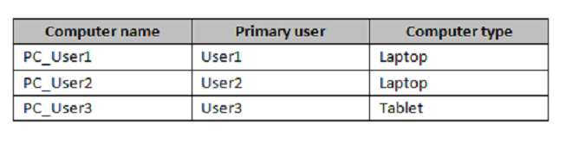
When User1 works remotely, the user fails to access shared folders on the corporate network.
When User 2 and User3 work remotely, they successfully connect to the shared folders on the corporate network.
You need to ensure that User1 can connect to the shared folders without user interaction. What should you do?
A. Click Turn on password protected sharing.
B. Disable Network Discovery.
C. Modify the Profile settings of an incoming firewall rule.
D. Run the Add-VpnConnectionTriggerApplication cmdlet.
E. Run the New-NetFirewallRule cmdlet and specify the -Direction Outbound parameter.
F. Run the New-VpnConnection cmdlet.
G. Run the Set-NetConnectionProfile cmdlet.
H. Run the Set-VPNConnection cmdlet

Question 74
Your network contains a single Active Directory domain named adatum.com. The network contains five servers configured as shown in the following table.
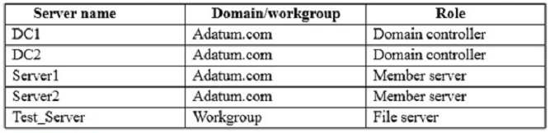
All of the servers run Windows Server 2012 R2.
Test_Server has a shared folder named ShareA. Only local users have permissions to ShareA. The network contains a mainframe computer that is administered by using the Telnet protocol. The domain contains four client computers configured as shown in the following table:
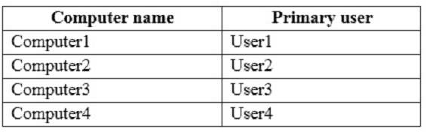
All of the client computers run the 64-bit version of Windows 10. User3 frequently accesses ShareA. Remote Desktop is enabled on Computer4.
Your company identifies the following requirements:
- Ensure that you can test unsigned device drivers on Computer1
- Enable Credential Guard on Computer2.
- Run commands and cmdlets remotely on computer2.
- Configure User Account control (UAC) on Computer3 to prompt administrators for credentials when elevated privileges are required. Ensure that User1 can view and interact with a desktop session of User3.
- Ensure that User2 can use Telnet to manage the mainframe.
- Ensure that User4 can use Remote Desktop to access Computer4 remotely.

You need to meet the requirement of Computer1. Which tool should you use on Computer1?

A. BCD Edit
B. Device Manager
C. Bootcfg
D. System Properties

Question 75
Using the scenario from question 74:
You need to recommend a solution to meet the requirements of User1. What should you include in the recommendation?
A. Remote Access Connection Manager
B. Remote Desktop
C. Remote Assistance
D. Windows PowerShell Remoting

Question 76
Using the scenario from question 74:
You need to meet the requirement for administering Computer2 remotely. Which remote management technology should you use?
A. Windows PowerShell remoting
B. Telnet
C. PsExec
D. Remote Desktop

Question 77
Using the scenario from question 74:
You need to meet the requirement of User4. What should you do?
A. Install a Universal Windows Platform (UWP) application.
B. Modify the settings of a firewall rule.
C. Install a Windows feature.
D. Modify the membership of a local group.

Question 78
You have a Key Management Service (KMS) host and an administrative workstation named Computer1.
From Computer1, you need to validate the activation status on a computer named Computer2.
What should you run?
A. Get-RDLicenseConfiguration computer2
B. slmgr.vbs computer2 /dlv
C. winrs.exe -r:Computer2 netdom.exe
D. ospp.vbs /tokact:computer2

Question 79
You have two computers named Computer1 and Computer2 that run Windows 10. On Computer1, you create a provisioning package named Package1. You plan to apply the provisioning package to Computer2.
Which file must be applied to Computer2?
A. Package1.icdproj.xml
B. Customizations.xml
C. Package1.ppkg
D. Package1.cat

Question 80
You have a computer named Computer1 that has the Hyper-V feature enabled.
You have two virtual machines named VM1 and VM2 hosted on Computer1. VM1 can communicate with VM2 and Computer1. VM1 fails to connect to the Internet-Computer1 can connect to the Internet.
You need to ensure that VM1 can connect to the Internet.
What should you do?
A. On Computer 1, modify the network settings.
B. Enable port mirroring on VM1.
C. Create an external virtual switch and configure VM1 to use the switch.
D. On VM1, select Enable virtual LAN identification.

Question 81
A user named User1 has a computer that runs Windows 10.
User1 reports that Cortana displays news topics that the user wants to suppress.
You need to suppress the news topics from being displayed.
What should you modify?
A. Reminders
B. the Location settings
C. the News app settings
D. Notebook

Question 82
Your network contains a single Active Directory domain named contoso.com. All computers are members of the domain and run the 64-bit version of Windows 10 Enterprise. On a test computer named Computer_Test1, you pin several company-specific applications in a group named Contoso Apps, and then you export the start menu layout to a file named contoso.xml. You install Client Hyper-V on a computer named Computer6.
You identify the following requirements:

Install the Hyper V feature on a computer named Computer1.
Use virtual smart card authentication on a computer named Computer2.
Enable Secure Boot on a computer named Computer3.
Connect a computer named Computer4 to a projector by using Miracast.
Ensure that a user named User1 can use keyboard shortcuts by pressing one key at a time.
Ensure that you can share the clipboard between Computer6 and the virtual machines running on Computer6. Add the Contoso Apps group to the Start menu of a computer named Computer7.

Which hardware feature must Computer2 support?

A. a smart card reader
B. Second Level Address Translation (SLAT)
C. Trusted Platform Module (TPM)
D. Unified Extensible Firmware Interface (UEFI)

Question 83
Your network contains a single Active Directory domain named contoso.com. All computers are members of the domain and run the 64-bit version of Windows 10 Enterprise. On a test computer named Computer_Test1, you pin several company-specific applications in a group named Contoso Apps, and then you export the start menu layout to a file named contoso.xml. You install Client Hyper-V on a computer named Computer6.
You identify the following requirements:
Install the Hyper V feature on a computer named Computer1.
Use virtual smart card authentication on a computer named Computer2.
Enable Secure Boot on a computer named Computer3.
Connect a computer named Computer4 to a projector by using Miracast.
Ensure that a user named User1 can use keyboard shortcuts by pressing one key at a time.
Ensure that you can share the clipboard between Computer6 and the virtual machines running on Computer6. Add the Contoso Apps group to the Start menu of a computer named Computer7.

Which hardware component is required for Computer1?

A. Trusted Platform Module (TPM)
B. Trusted Boot
C. Second Level Address Translation (SLAT)
D. Secure Boot

Question 84
Your network contains a single Active Directory domain named contoso.com. All computers are members of the domain and run the 64-bit version of Windows 10 Enterprise. On a test computer named Computer_Test1, you pin several company-specific applications in a group named Contoso Apps, and then you export the start menu layout to a file named contoso.xml. You install Client Hyper-V on a computer named Computer6.
You identify the following requirements:
Install the Hyper V feature on a computer named Computer1.
Use virtual smart card authentication on a computer named Computer2.
Enable Secure Boot on a computer named Computer3.
Connect a computer named Computer4 to a projector by using Miracast.
Ensure that a user named User1 can use keyboard shortcuts by pressing one key at a time.
Ensure that you can share the clipboard between Computer6 and the virtual machines running on Computer6. Add the Contoso Apps group to the Start menu of a computer named Computer7.

Which hardware feature must Computer3 support?
A. Data Execution Prevention (DEP)
B. Unified Extensible Firmware Interface (UEFI)
C. Trusted Platform Module (TPM)
D. Second LevelAddress Translation (SLAT)

Question 85
You purchase a new USB drive. You apply a custom image of Windows to the USB drive.
You plan to modify the BIOS setting on a computer so that the computer can start from the USB drive. You need to ensure that you can start the computer by using the USB drive.
What should you run?
A. Add-Windows Image
B. bcdboot.exe
C. bcdedit.exe
D. bootcfg.exe
E. bootim.exe
F. bootsect.exe
G. diskpart.exe
H. Expand-Windows Image

Question 86
You have a computer named Computer1. Computer1 has a virtual hard disk (VHD) named Disk1.vhdx. Windows is installed on Disk1.vhdx. Disk1.vhdx is visible in File Explorer as drive E.
You need to configure Computer1 to start from Disk1.vhdx. Hardware virtualization must not be available when Computer1 starts from Disk1.vhdx.
What should you run?
A. Add-Windows Image
B. bcdboot.exe
C. bcdedit.exe
D. bootcfg.exe
E. bootim.exe
F. bootsect.exe
G. diskpart.exe
H. Expand-Windows Image

Question 87
You have a computer named Computer1 that has a virtual hard disk (VHD) named Disk1.vhdx.
You plan to configure Computer1 for dual boot from Disk1.vhdx.
You need to install Windows on Disk1.vhdx by using dism.exe.
What should you run before you install Windows?
A. Add-Windows Image
B. bcdboot.exe
C. bcdedit.exe
D. bootcfg.exe
E. bootim.exe
F. bootsect.exe
G. diskpart.exe
H. Expand-Windows Image

Question 88
You have a custom Microsoft Management Console (MMC) named Console 1 that contains several snapins.
Users use Console1 to manage specific computer settings. Users report that every time they close Console1, they are prompted to save the MMC.
You need to prevent the prompts to save Console1.
What should you do?
A. From the Details settings of the MMC file, modify the Authors property.
B. From the File menu, click Add/Remove Snap-in. and then click Edit Extensions.
C. From the File menu, click Options and then modify the console mode.
D. From the Security settings of the MMC file, modify the permissions.

Question 89
Your network contains a single Active Directory domain named contoso.com. The domain contains a computer named Computer1.
You have five users configured as shown in the following table:
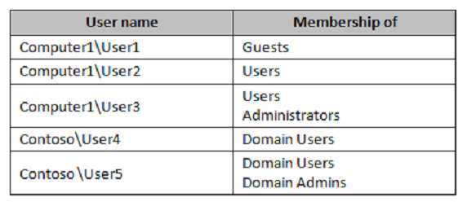
Which two users can add a Microsoft account to their Windows account, and then sign in to Computer1 by using the Microsoft account?
A. User1
B. User2
C. User3
D. User4
E. User5

Question 90
You have a computer that has a shared printer named Printer1. The Advanced settings for Printer1
are configured as shown:
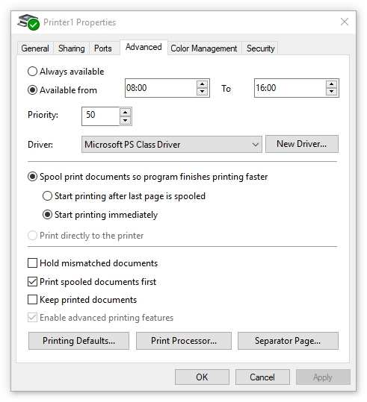

The Security settings for Printer1 are configured as shown:
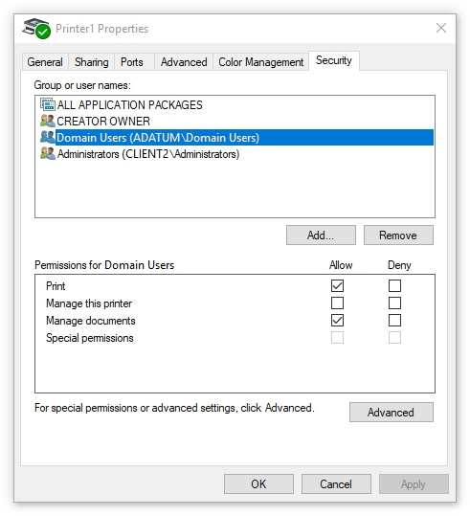
You run the Get-PrintJob cmdlet and you receive the following output:
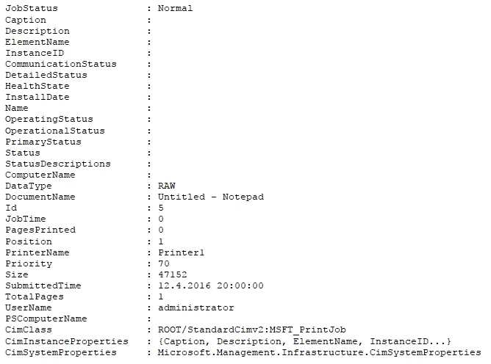
The job in the print queue will be printed immediately: Yes or No? NO
If a new print job is sent to Printer1 the new print job will be printed before the print job that is in the queue already: Yes or No? NO
A domain user named User1 can cancel a print job in the print queue: Yes or No? YES

Question 91
You have a computer named Computer1 that runs Windows 10. You need to register Computer1 with Microsoft Intune.
What should you do?
A. From Accounts in the Settings app, click enroll in to device management.
B. From a command prompt, run the djoin command and specify the /psite parameter.
C. From System in Control Panel, modify the domain membership.
D. From Accounts in the Settings app, add a Microsoft account.

Question 92
You are evaluating a third-party antivirus application on a computer.
You attempt to uninstall the application, but the application fails to uninstall.
You need to remove the antivirus application from the computer. The solution must preserve user data and installed applications.
What should you do?
A. Perform a driver rollback.
B. Perform a restore by using File History.
C. Restore a System Restore point.
D. Use the Reset this PC option

Question 93
IPv6 has a vastly larger address space than IPv4. This expansion provides flexibility in allocating addresses and routing traffic and eliminates the primary need for network address translation (NAT).
Do you know how many more bits there are in an IPv6 address compared to an IPv4 address?
A. 4 times more
B. 6 times more
C. Twice as many
D. 8 times more

Question 94
You have a computer named Computer1 that runs Windows 10. Computer1 uses the Current Branch servicing option. Microsoft releases an upgrade to the Current Branch. The upgrade is installed on Computer1.
You need to revert Computer1 to the previous version of Windows 10.
Which tool should you use?
A. Programs and Features from Control Panel
B. Windows Update from the Settings app
C. Recovery from the Settings app
D. System from Control Panel

Question 95
You have a computer named Computer1 that runs Windows 10.
Computer1 is infected by a virus.
You fail to access the Settings app on Computer1 due to the virus.
You need to restart the computer and ensure that Computer1 displays the advanced startup options when the computer restarts.
What are two possible ways to achieve the goal? Each correct answer presents a complete solution.

A. From Windows PowerShell, run Restart-Computer Computer1 - Wait - For PowerShell.
B. From System Configuration select safe boot select minimal, and then click Restart from the Start menu.
C. From system Configuration, select selective startup, and then click Restart from the start menu.
D. From a command prompt, run shutdown.exe /r/o.
E. From Power on the start menu, hold the SHIFT key while you click Restart.

Question 96
Your network contains a single Active Directory domain. The domain contains a laptop named Computer1 I that runs Windows 10.
A user named User1 uses Computer1. Computer1 connects to two shared printers named Printer1 and Printer2.
Printer1 is located at the office and Printer2 is located at the home of User1.
User1 frequently reports that when attempting to print, the default printer is set to Printer2.
You need to ensure that Printer1 is the default printer always.
What should you do?
A. Add Printer 2 to a home group.
B. Disable Let Windows manage my default printer.
C. Change the priority of Printer1 to 1.
D. Change the priority of Printer2 to 1.

Question 97
A user named User1 has a laptop that runs Windows 10 Pro.
At home, User1 connects to the home network by using an Ethernet connection. User1 reports that he sometimes exceeds his Internet data limit.
You need to prevent the laptop from downloading Windows updates automatically. What should you do?
A. From a local Group Policy, modify the Windows Update settings.
B. From a local Group Policy, modify the Network Connections settings.
C. From the Settings app. configure a metered connection.
D. From the Settings app, select Defer upgrades.

Question 98
A user fails to connect a mouse to a computer.
The user sends you the following output:
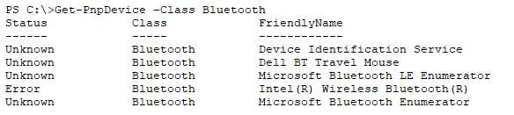
Select the correct two answers
A Bluetooth mouse is ready to pair
A Bluetooth mouse is paired and working
A Bluetooth mouse is paired and unresponsive
The error occurs because the computer is in airplane mode
The error occurs because Bluetooth is turned off in the Settings app
The error occurs because the Bluetooth adapter is disabled in device manager

Question 99
You have three computers configured as shown in the following table.
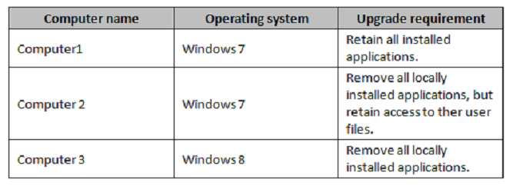
You plan to migrate the computers to Windows 10.
Which installation option should you use for each computer?

Computer1 Custom or Upgrade?
Computer2 Custom or Upgrade?
Computer3 Custom or Upgrade?

