A+
IEEE  Standard | Operating  Frequency | Typical Data Rate | Maximum  Data Rate | Indoor Range | Outdoor Range
802.11b | 2.4 Ghz | 6.5 Mbps | 11 Mbps | 35 Meters | 100 Meters
802.11a | 5 Ghz | 25 Mbps | 54 Mbps | 35 Meters | 125 Meters
802.11g | 2.4 Ghz | 25 Mbps | 54 Mbps | 25 Meters | 75 Meters
802.11n | 2.4 Ghz or 5 Ghz | 200 Mbps | 540 Mbps | 50 Meters | 125 Meters
802.11ac | 5 Ghz | 2.5 Gbps | 6.9 Gbps | 50 Meters | 125 Meters

Wifi Standards

Bluetooth Classes
Device Class | Transmit Power | Intended Range
Class 1 | 100 mW | 100 Meters (328 feet)
Class 2 | 2.5 mW | 10 Meters (33 feet)
Class 3 | 1 mW | Less than 10 Meters

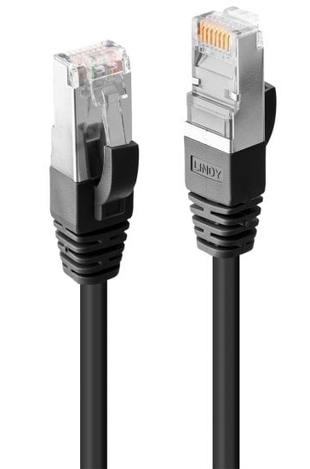

Cable Categories
Type | Speed | Common Use
CAT1 | 1 Mbps | Phone lines
CAT2 | 4 Mbps | Token ring networks
CAT3 | 16 Mbps | Ethernet networks
CAT4 | 20 Mbps | Token ring networks
CAT5 | 100 Mbps | Ethernet networks
CAT5e | 1 Gbps | Ethernet networks
CAT6 | 10 Gbps | Ethernet networks
CAT7 | 10 Gbps | Ethernet networks  (fully shielded cable)

Service | Port | Description
Apple filing protocol (AFP) | TCP 548 or 427 | Formerly called AppleTalk Protocol; file services macOS
Common Internet file system | TCP 445 | A version of Server Message Block (SMB)
Domain Name System | UDP 53 | Used by DNS clients to perform DNS queries against clients
Dynamic Host Configuration Protocol | TCP/UDP 67/68 | Used for assigning IP addresses to clients
File Transfer Protocol (FTP) | TCP 20/21 | Transfers file between an FTP client and FTP server
Hypertext Transfer Protocol (HTTP) | TCP 80 | Web page transmission to the web browser
HTTP over Secure Sockets Layer/Transport Layer Security | TCP 443 | Secure transmission of web pages
Internet Message Access Protocol (IMAP4) | TCP 143 | Retrieves e-mail; advanced features beyond POP3, such as folder synchronization
Lightweight Directory Access Protocol (LDAP) | TCP 389 | A standard method of accessing a network database; often used for authenticating user accounts during a user logon
Post Office Protocol Version 3 (POP3) | TCP 110 | Retrieves e-mail from a POP3 mail server

Well known Ports
Service | Port | Description
Remote Desktop Protocol (RDP) | TCP 3389 | Used remotely access a Windows desktop
Secure File Transfer Protocol | TCP 22 | Uses an SSH-encrypted terminal emulation that replaces telnet
Secure Shell (SSH) | TCP 22 | Secure (encrypted) terminal emulation that replaces Telnet
Server Message block | TCP 445 or TCP 137 -139 | Windows file and print sharing service
Service Location Protocol (SLP) | TCP/UDP 427 | A LAN service discovery protocol used by older versions of macOS, NetWare, and some LAN–enabled printers
Simple Mail Transfer Protocol (SMPT) | TCP 25 | Sending e-mail
Simple Network Management Protocol (SNMP) | UDP 161/162 | Queries network devices for status and statistics
Telnet | TCP 23 | Terminal emulation; all data sent in clear text
Trivial File Transfer Protocol | UDP 69 | Differs from FTP in that there is no option for authentication

Linux Commands
Command | Use
ls | Lists files
grep | Search plain-text data sets
cd | Changes Directory
shutdown | Shutdown PC
pwd | Print the current directory
passwd | Used to change password of current user
mv | Move files
cp | Copy files
rm | Removes files
chmod | Change the access permissions
chown | Change the owner of file systems
ifconfig | Shows all connected interfaces
iwconfig | Shows wireless connections
mkdir | Makes a new directory
ps | Show current running processes
su | Change current user
sudo | Execute commands which need admin rights
apt-get | Install applications
vi | Graphical text editor
dd | Copy and convert files
kill | Used to stop or kill a process
nano | Text editor
cat | Shows the text inside a file

Command | Use
- dir | List the content of one or more directory
- cd | Change directories
- .. | Go up one level in the directory tree
• ipconfig | View network adapter settings and values
• ping | Test and send information to another network computer or network adapter
• tracert | View network packets route across a network
• netstat | Display the TCP/IP network protocol statistics and information
• nslookup | Look up an IP address of a domain or host on a network
• shutdown | Shutdown the computer
• dism | Deployment Image Servicing and Management
• sfc | System file checker to scan and restore your files
• chkdsk | Check the hard drive running FAT for errors
• diskpart | Manage PC drives, partitions, volumes or virtual HDDs
• taskkill | Kill a task (end a program)
• gpupdate | Update group policy
• gpresult | Display the group policy objects that are applied to a user and computer
• format | Formats a drive
• copy | Copy one or more files to a different location
• xcopy | Copy multiple files, directories, or drives from one location to another
• robocopy | A robust file copy command
• net use | Connect to, remove and configure connections to mapped drives or resources
• net user | Add, remove or make changes to the user accounts
[Command]/? | Get help of what the command does

Windows Commands
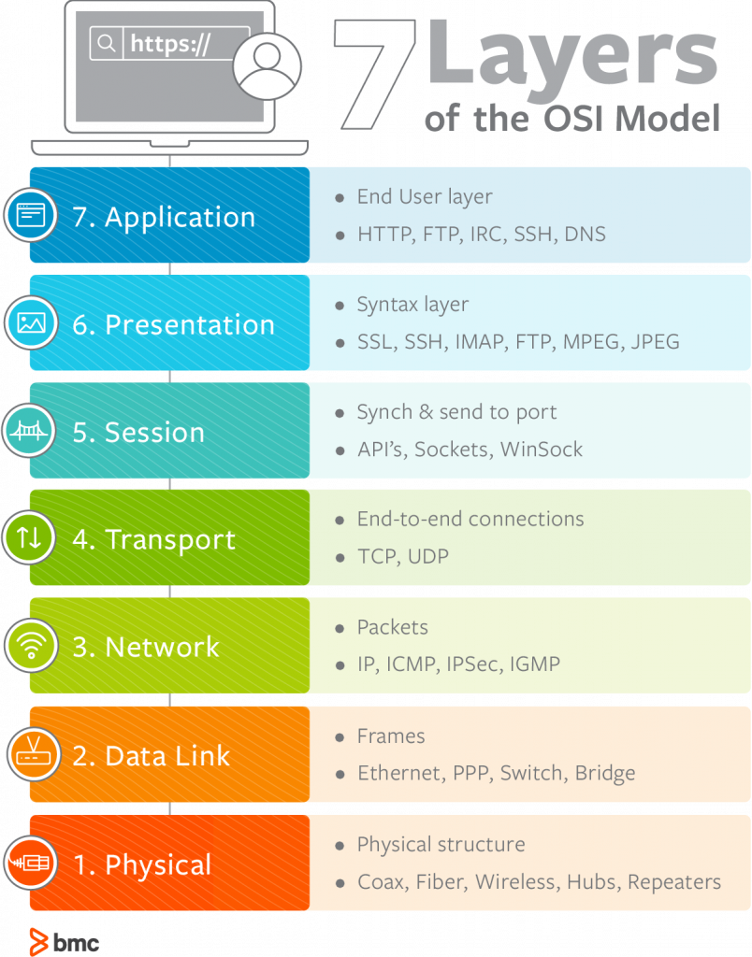
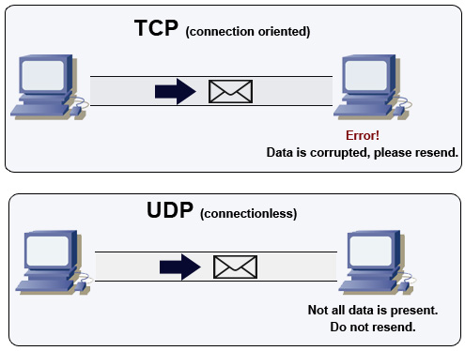

TCP vs UDP

And OSI layer

